**[GitHub - solegalli/feature-engineering-for-machine-learning: Code repository for the online course Feature Engineering for Machine Learning](https://github.com/solegalli/feature-engineering-for-machine-learning)**

**What exactly is a variable?**

A variable is any

characteristic, number, or quantity that c

an be **measured or counted**.

They are called "variables" because **the value they take may vary,** and it usually does. The following are examples of variables:

* Age (21, 35, 62,...)
* Gender (male, female)
* Income (GBP 20000, GBP 35000, GBP 45000,...)
* House price (GBP 350000, GBP 570000,...)
* Country of birth (China, Russia, Costa Rica, etc.)
* Eye colour (brown, green, blue,...)
* Vehicle make (Ford, Volkswagen,...)

Most variables in a data set can be classified into one of two major types:

* **Numerical variables**
* **Categorical variables**

===================================================================================

**Numerical variables**

The values of a **numerical variable are numbers**. They can be further classified into:

* **Discrete variables**
* **Continuous variables**

**Discrete variables**

In a discrete variable, the values are **whole numbers (counts).** For example, the **number of items bought by a customer** in a supermarket is discrete. The customer can purchase one, twenty-five, or fifty items, but not 3.7 items.It is always a round number. The following are examples of discrete variables:

* Number of active bank accounts of a borrower (1, 4, 7,...)
* Number of pets in the family
* Number of children in the family

**Continuous variables**

A variable that may **contain any value within a range is continuous**. For example, the total amount paid by a customer in a supermarket is continuous. The customer can pay **GBP 20.5, GBP 13.10, GBP 83.20 and so on. Other examples of continuous variables are:**

* House price (in principle, it can take any value) (GBP 350000, 57000, 100000,...)
* Time spent surfing a website (3.4 seconds, 5.10 seconds,...)
* Total debt as a percentage of total income in the last month (0.2, 0.001, 0, 0.75,...)

=============================================================================

**In this demo: Peer-to-peer lending (Finance)**

In this demo, we will use a toy data set that simulates data from a peer-to-peer finance company.

To obtain the data, go to the lecture **Download datasets** in **Section 1**. This is a toy dataset that I created and comes within the Datasets.zip file that you can find in this lecture.

In [1]:

**import** pandas **as** pd

**import** numpy **as** np

**import** matplotlib.pyplot **as** plt

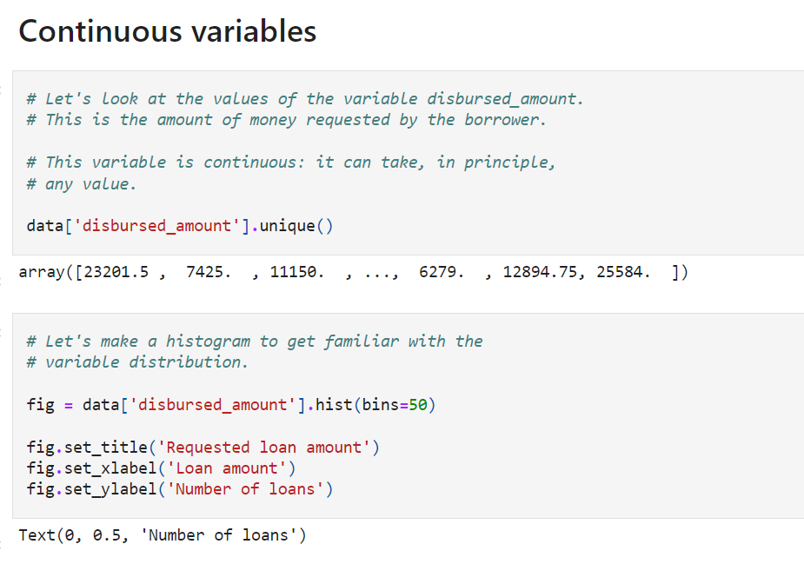

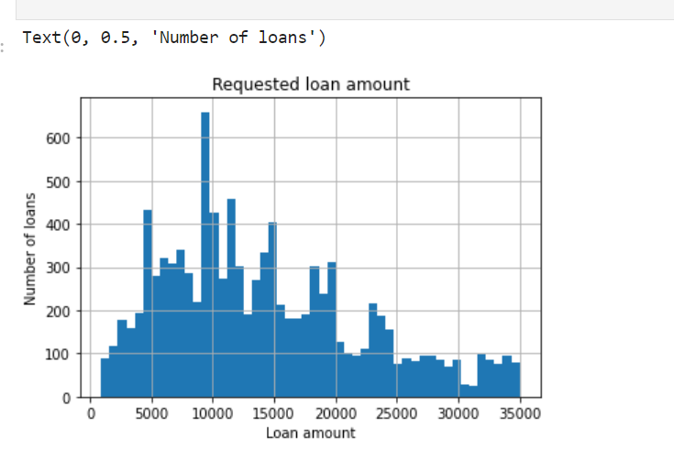

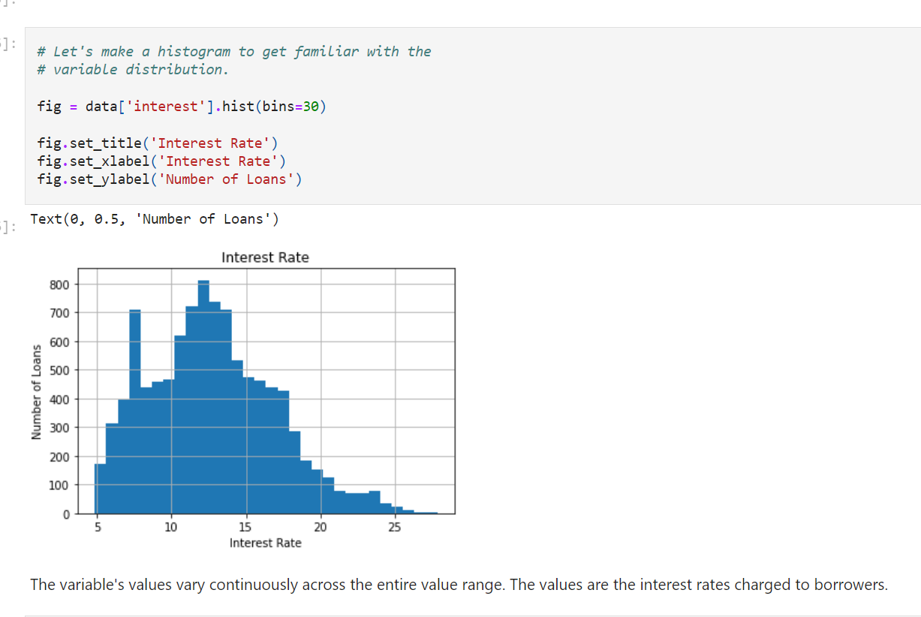

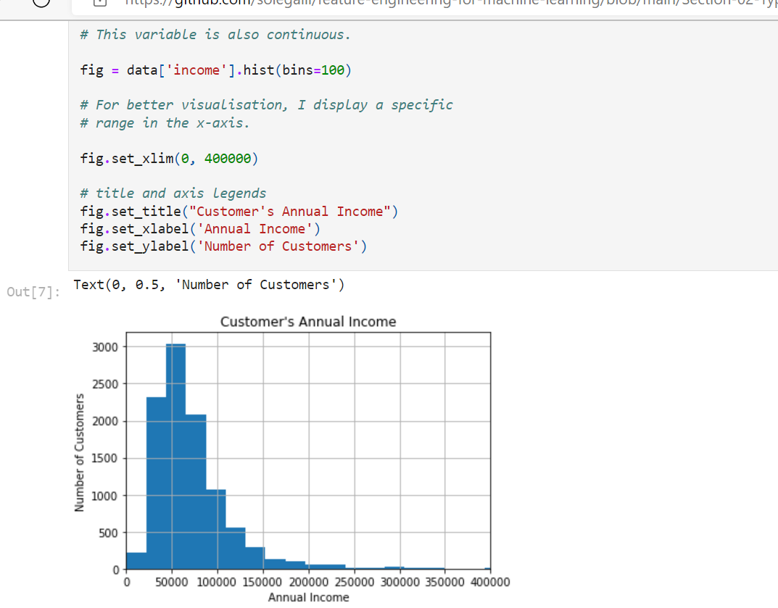

**Discrete variables**

Let's explore the variable "Number of open credit lines in the borrower's credit file" ("number_open_accounts" in the dataset).

This variable represents the borrower's total number of credit items (for example, credit cards, car loans, mortgages, etc.).

By definition, it is a discrete variable, because a borrower can have **1 credit card, but not 3.5 credit cards.**

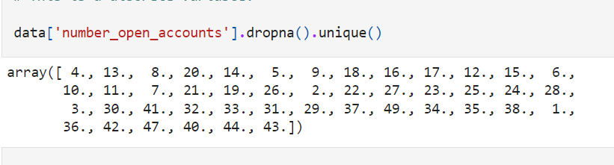

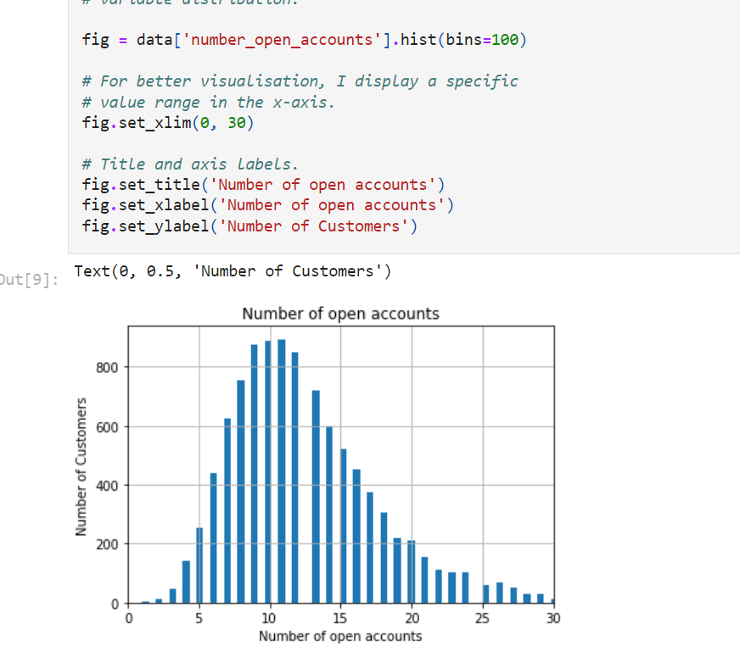

Because not all of the values within the variable range are present in the variable, histograms of **discrete variables show this typical broken form.**

Let's look at another example of a discrete variable in this dataset: **Number of installment accounts opened in the previous 12 months** (in the dataset, 'number_credit_lines_12').

Installment accounts are ones that have a **defined length and quantity of repayments agreed upon between the lender and the borrower** at the time of acquisition. A car loan or a student loan are two examples of this. The borrower understands that they will pay a set amount over a set length of time, **such as 36 months.**

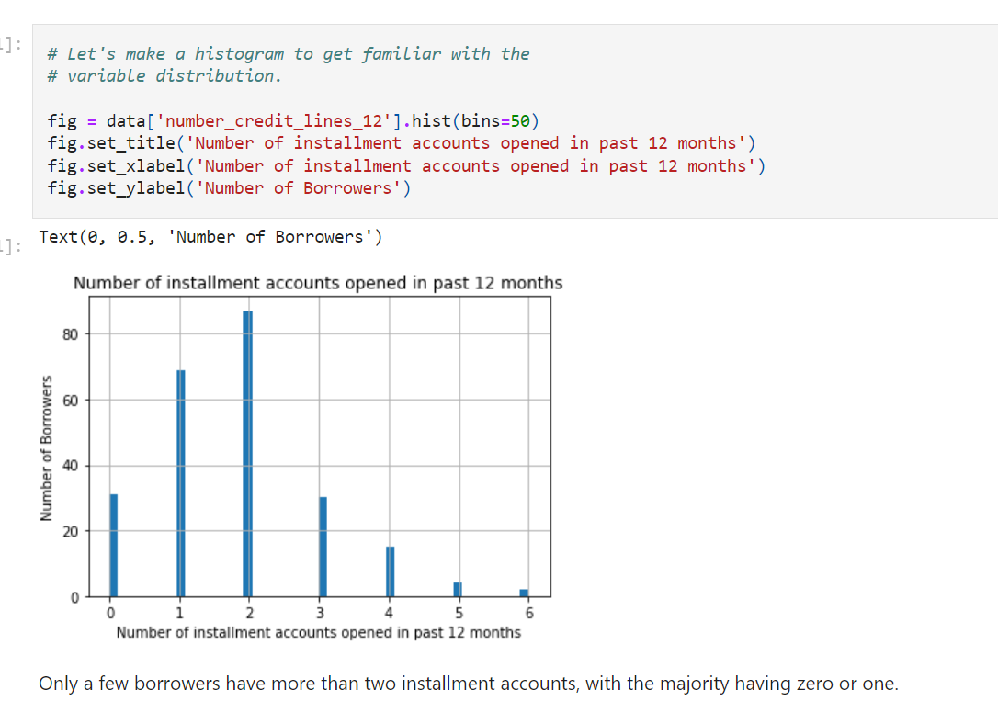

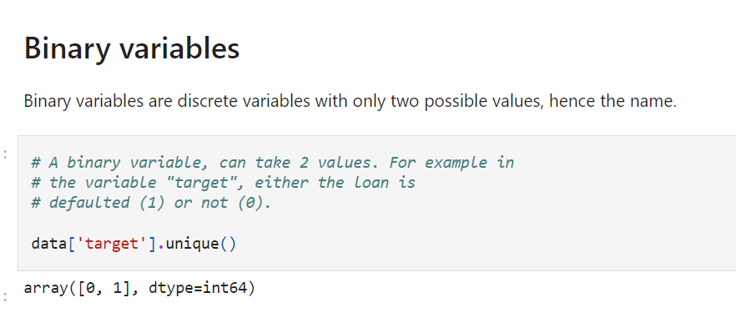

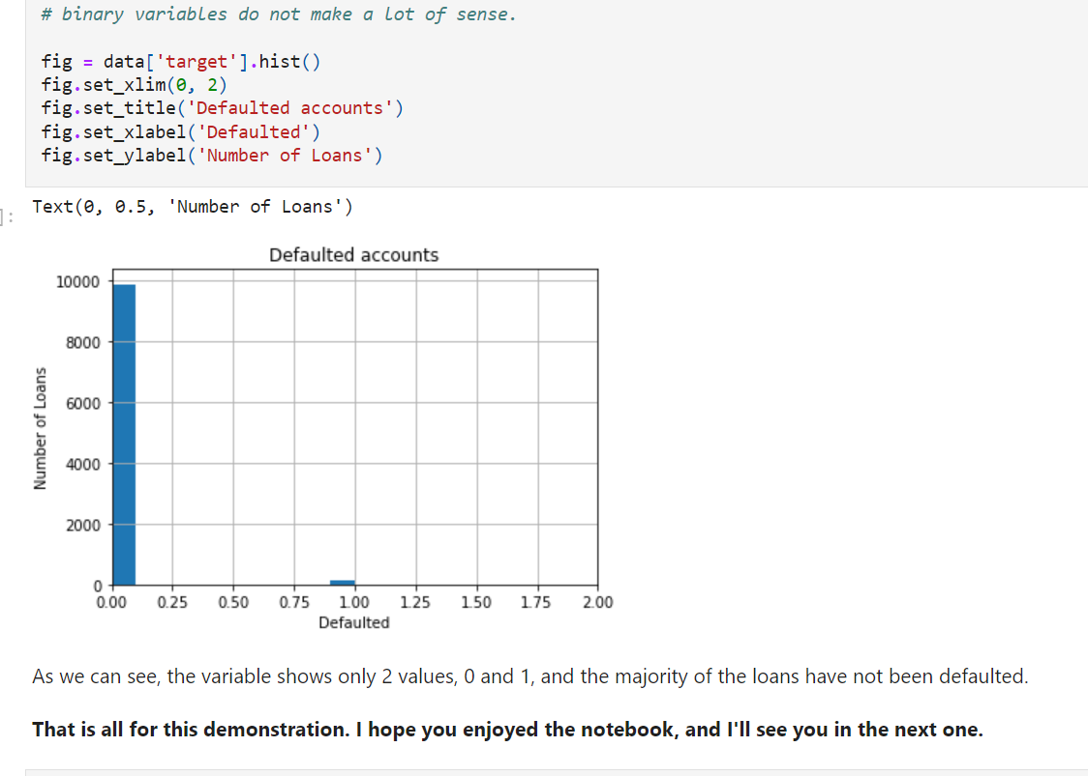

**Categorical Variables**

The values of a categorical variable are selected from a group of **categories**, also called **labels**. Examples are **gender (male or female**) and **marital status (single, married, divorced, or widowed).** Other examples of categorical variables include:

* Intended use of loan (debt-consolidation, car purchase, wedding expenses, etc.)
* Mobile network provider (Vodafone, Orange,...)
* **Postcode**

Categorical variables can be further categorised into:

* **Ordinal Variables**
* **Nominal variables**

**Ordinal variables**

Ordinal variables are categorical variables whose categories can be **meaningfully ordered**. For example:

* **Student's grade** on an exam (A, B, C, or Fail).
* **Days of the week**, where Monday is 1 and Sunday is 7.
* **Educational level, with the categories of elementary school, high school, college graduate, and PhD ranked from 1 to 4.**

**Nominal variables**

There is no inherent order in the labels for nominal variables. Country of birth, for example, has nominal values of Argentina, England, Germany, and so on. Nominal variables include the following:

* Car color (blue, grey, silver,...)
* Vehicle make (Citroen, Peugeot,...)
* City (Manchester, London, Chester,...)

In principle, there is nothing that indicates an intrinsic order to the labels, and in fact, they are all equal.

**To be considered:**

Sometimes categorical variables are **coded as numbers** (e.g., gender may be coded as **0 for males and 1 for females).** The variable is **still categorical**, despite the use of numbers.

In a similar way, individuals in a survey may be coded with a number that uniquely identifies them (for example, to avoid storing personal information). This number is really a label, and the variable is then categorical. **The number has no importance other than to allow the observation to be uniquely identified.**

When working with a dataset in a commercial setting, it's ideal if the data comes with a dictionary that specifies whether the numbers in the variables are to be considered categories or numerical. If the numbers are categories, the dictionary will explain what each variable's value signifies.

=============================================================================

**In this demo: Peer-to-peer lending (Finance)**

In this demo, we will use a toy data set that simulates data from a peer-to-peer finance company.

To obtain the data, go to the lecture **Download datasets** in **Section 1**. This is a toy dataset that I created and comes within the Datasets.zip file that you can find in this lecture.

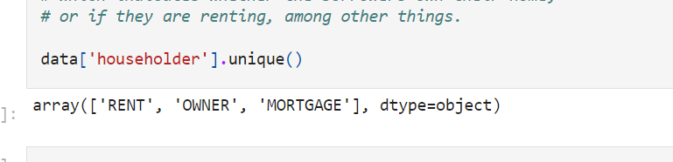

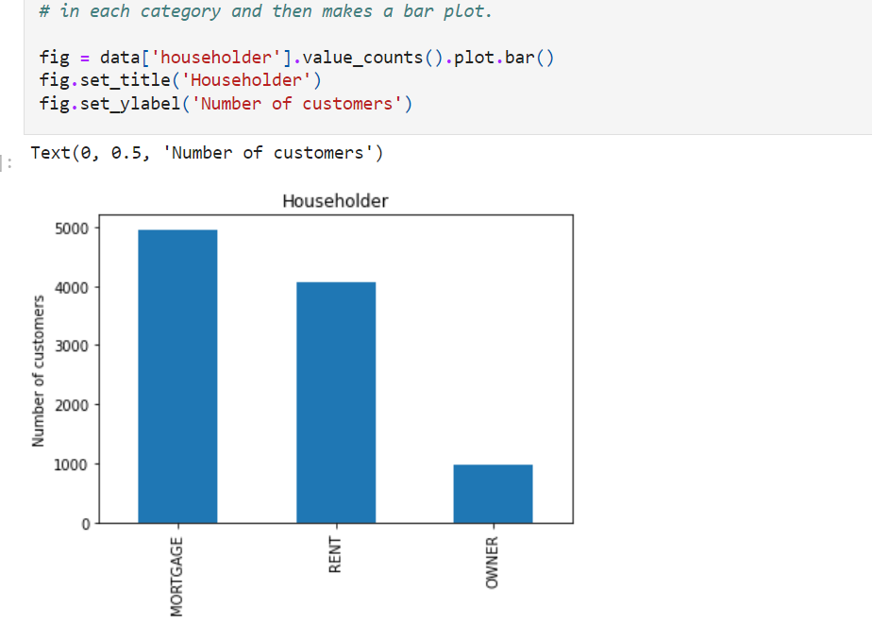

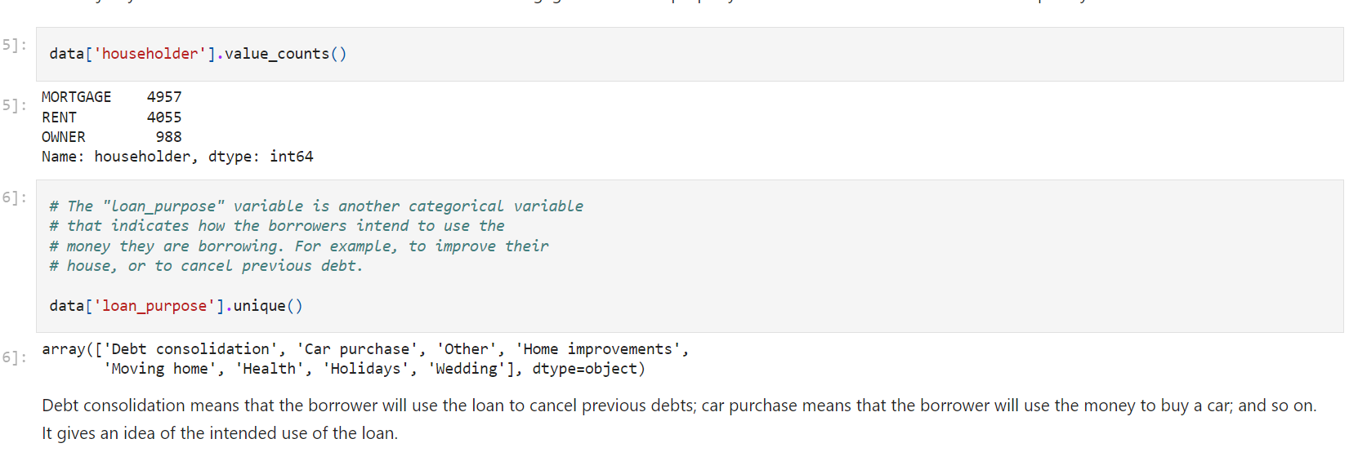

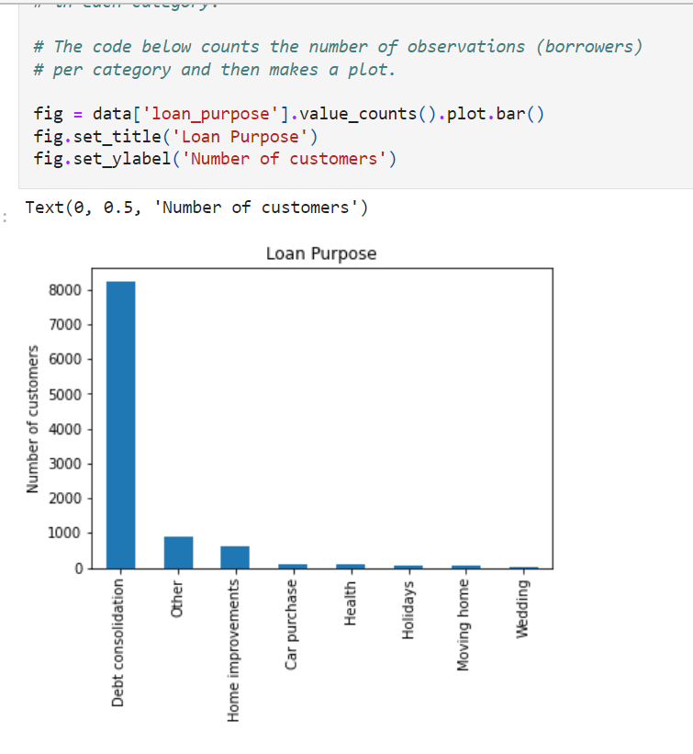

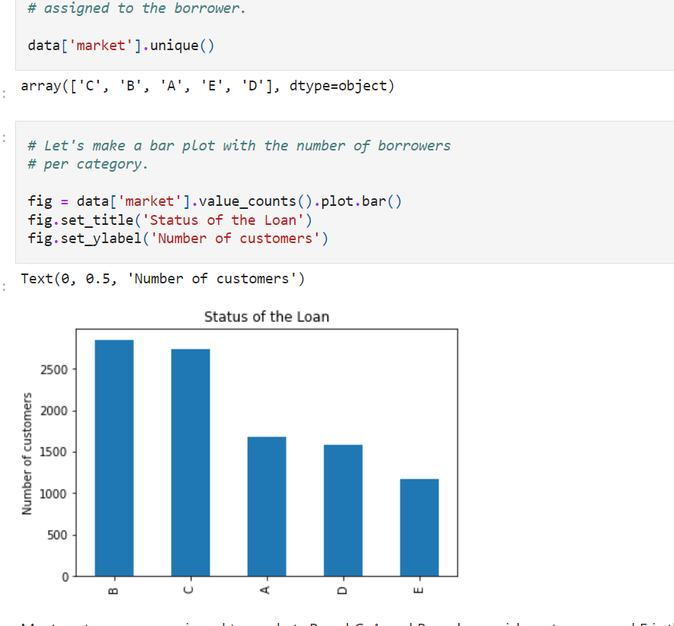

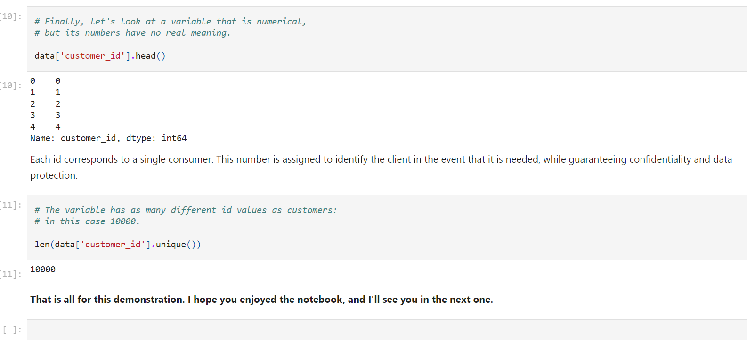

Variable that is numeric but has no real meaning

**Datetime variables**

Datetime variables take dates and / or time as values. For example, date of birth ('29-08-1987', '12-01-2012'), or date of application ('2016-Dec', '2013-March'). Datetime variables can contain dates only, times only, or dates and time.

We don't use datetime variables straightaway in machine learning because:

* They contain a huge number of different values.
* We can extract much more information from datetime variables by preprocessing them correctly.

Furthermore, date variables frequently include dates that were absent from the dataset used to train the machine learning model. In fact, date variables are frequently used to store dates that are in the future in comparison to the dates in the training dataset. As a result, because they were never seen while being trained, the machine learning model will have no idea what to do with the new values.

=============================================================================

**In this demo: Peer-to-peer lending (Finance)**

In this demo, we will use a toy data set that simulates data from a peer-to-peer finance company.

To obtain the data, go to the lecture **Download datasets** in **Section 1**. This is a toy dataset that I created and comes within the Datasets.zip file that you can find in this lecture.

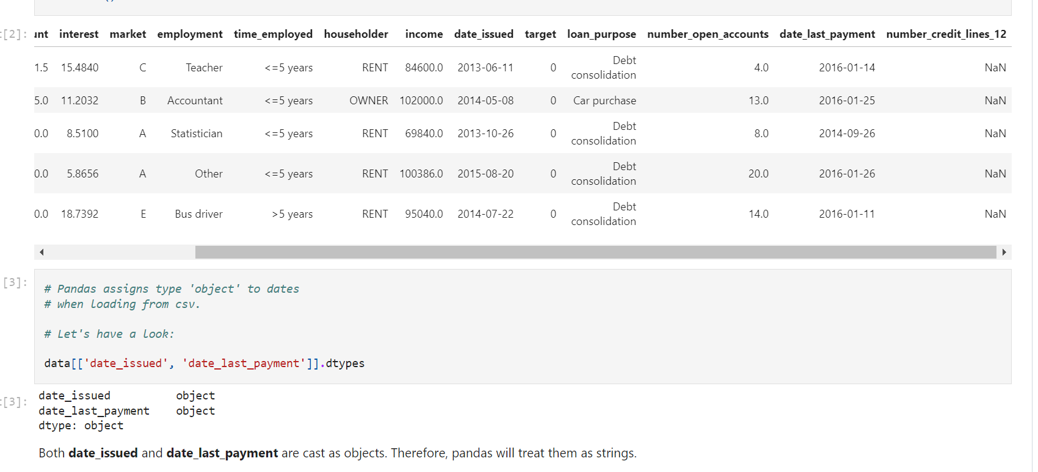

They are in object form ,

Pandas will treat them as string

Need to convert to datetime

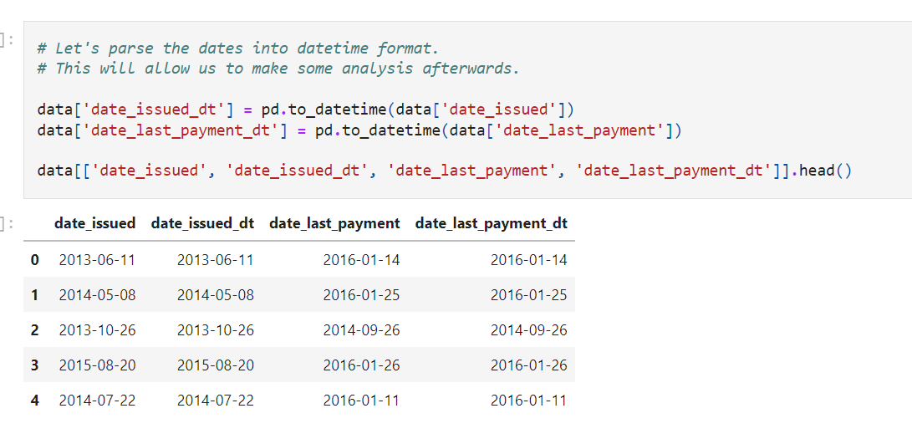

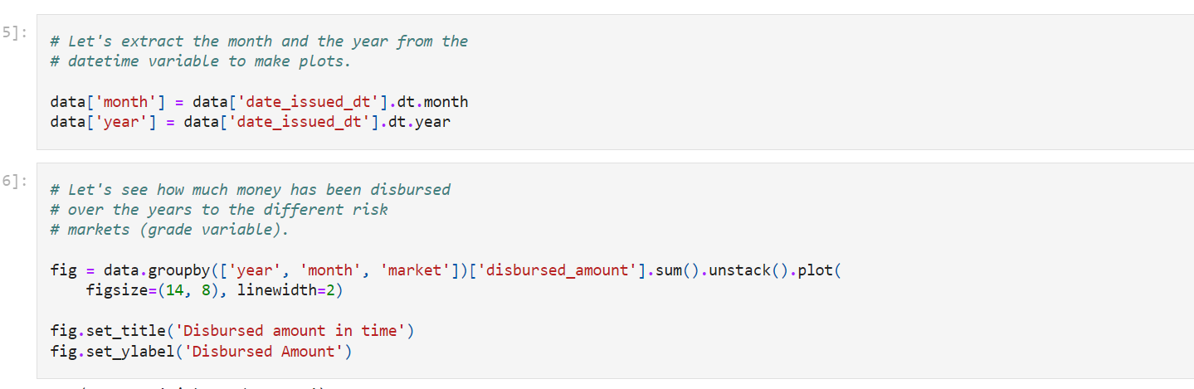

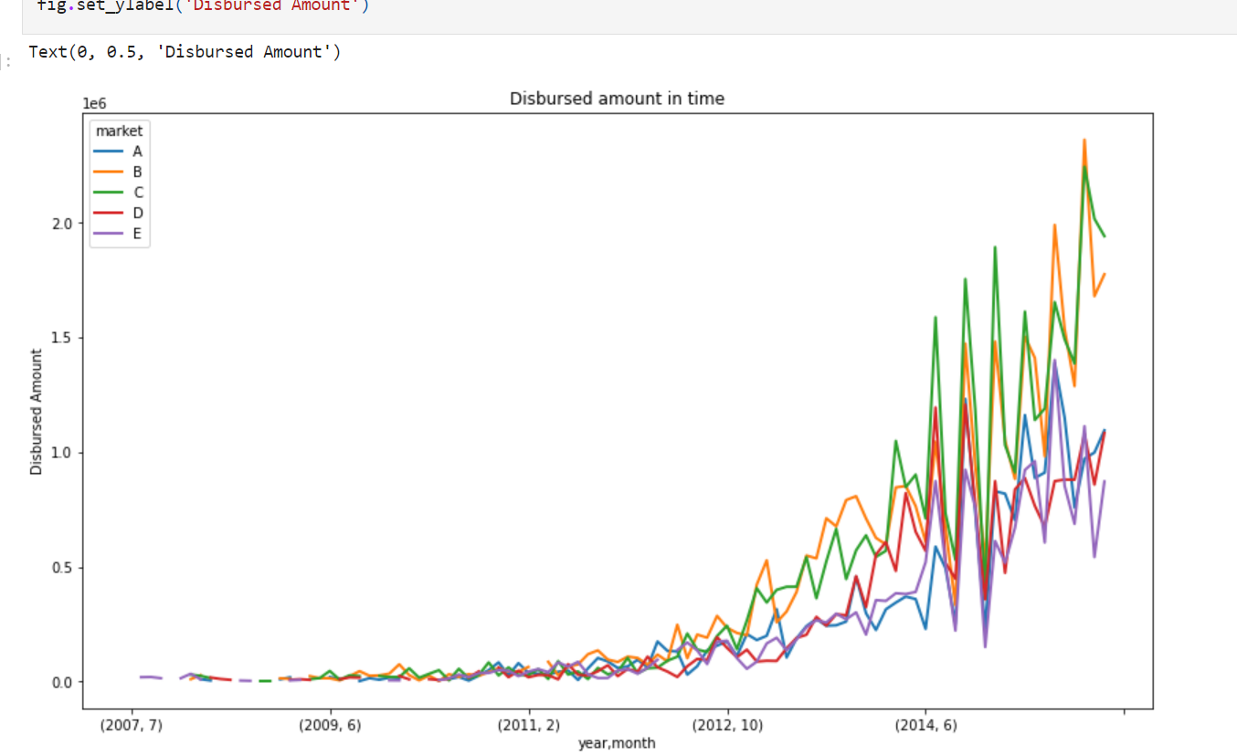

**Mixed Variables**

Mixed variables are those whose values **contain both numbers and labels**.

Variables can be mixed for a variety of reasons.

Either number or lable

But not together

Some has both numbers and category

Ex: financial variable s

For example, when credit agencies gather and store **financial information about users, usually the values of the variables they store are numbers**.

However, in some cases, the credit agencies cannot retrieve information for a certain user for various reasons. What credit agencies do in these situations is to code each different reason for which they failed to retrieve information with a different code or "label". Like this, they **generate mixed-type variables.** These variables contain numbers when the value could be retrieved, or labels otherwise.

As an example, think of the variable "number_of_open_accounts". It can take any number, representing the number of different financial accounts of the borrower. Sometimes, information may not be available to a certain borrower for a variety of reasons. Each reason will be coded by a different letter. For example, "A": couldn't identify the person, "B": no relevant data, "C": person seems not to have any open accounts.

Another example of a mixed variable is the variable "missed_payment_status." This variable indicates whether a borrower has missed a (any) payment on their financial item. For example, if the borrower has a credit card, this variable indicates whether they missed a monthly payment on it. Therefore, this variable can take values of 0, 1, 2, 3, meaning that the customer has missed 0–3 payments in their account. And it can also take the value "D" if the customer defaulted on that account.

Typically, once the customer has missed 3 payments, the lender declares the item defaulted (D). That is why this variable takes numerical values 0–3 and then D.

For this demo, you will need to download a toy csv file called sample_s2.csv. The file comes in the Dataset.zip file available in Section 1, in the lecture called **Download datasets**.

**Note**: the dataset is also attached as a download-able resource to the video lecture corresponding to this notebook.

--

**Variable characters:**

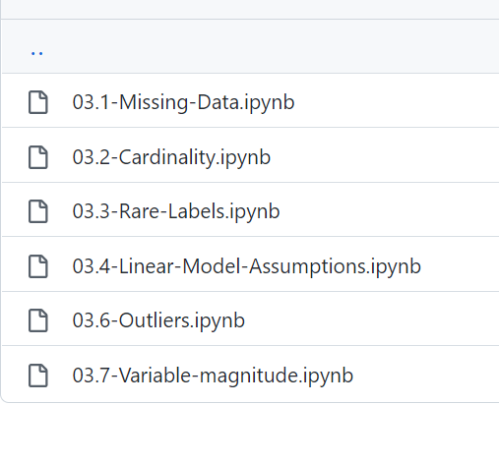

**Missing data**

**Categorical variables**

**Distributions**

**Outliers**

**Feature magnitude(Scale of different features)**

**Missing values**

Missing data is the **absence of values in certain observations** of a variable. Missing data is an **unavoidable problem i**n most data sources and may have a **significant impact on the conclusions** that we derived from the data.

**Why is the data missing?**

The source of missing data can vary. These are just some examples:

* The value was forgotten, lost, or not stored properly.
* The value does not exist.
* The value can't be known or identified.

To give real-life examples, a **person may choose not to complete all fields in a form if they are not mandatory.** That would introduce missing data. Sometimes **people do not want to disclose some information,** for example, income, or they do not know the answers to the questions being asked.

Sometimes the value for a certain **variable does not exist**. For example, in the variable "total debt as percentage of total income" (very common in financial data), if the person has no income, then the total percentage of 0 does not exist, and therefore it will be a missing value.

It's important to understand why data is missing, in other words, the mechanism of missing data. We may process the missing information differently depending on this mechanism. Furthermore, identifying the source of missing data allows us to take steps to regulate that source and reduce the amount of missing data as data collection progresses.

**Missing data mechanisms**

**There are 3 mechanisms that lead to missing data.** Two of them involve **missing data randomly** and the third one involves a **systematic loss of data.**

**MCAR**

**MAR**

**MNAR**

**Missing Completely at Random, MCAR:**

If the likelihood of **a value being missing is the same for all observations**, the variable is missing completely at random (MCAR). The data points that are missing are a random subset of the observations.

Absolutely no relation between missed values and other variables

If data is MCAR, then disregarding observations with missing data would not bias the inferences made.

They are random subset of data

**Missing at Random, MAR:**

If the probability of an **observation being missing depends on available information** (i.e., other variables), then the observation is missing at random (MAR). **There is a relationship between the likelihood of a value being missing and the observed data.**

**Probability of missing data based on available information**

For example, if **men are more likely to disclose their weight** than women, weight is MAR. The weight information will be missing at random for the men and women who did not disclose their weight, but as men are more prone to disclose it, there will be **more missing values for women than for men.**

In this example, missing data points are **no longer a random subset of the total observations.**

If we decide to proceed with the variable with missing values (in this case weight), **we might want to include the variable gender to control the bias in weight for the missing observations**.

We should add gender

**Missing Not at Random, MNAR:**

If there is a **mechanism or a reason why data is missing**, then that data is **missing not at random** (MNAR). For example, **if people failed to fill out a depression survey** because **of their depression,** those data points would be missing not at random. The missing data occurs due to the depression.

Depending on the mechanism by which missing values occur, we may choose different missing data imputation methods.

More null values for depressed patients(as they don’t want to fill the data)

Less null values for non depressed patients

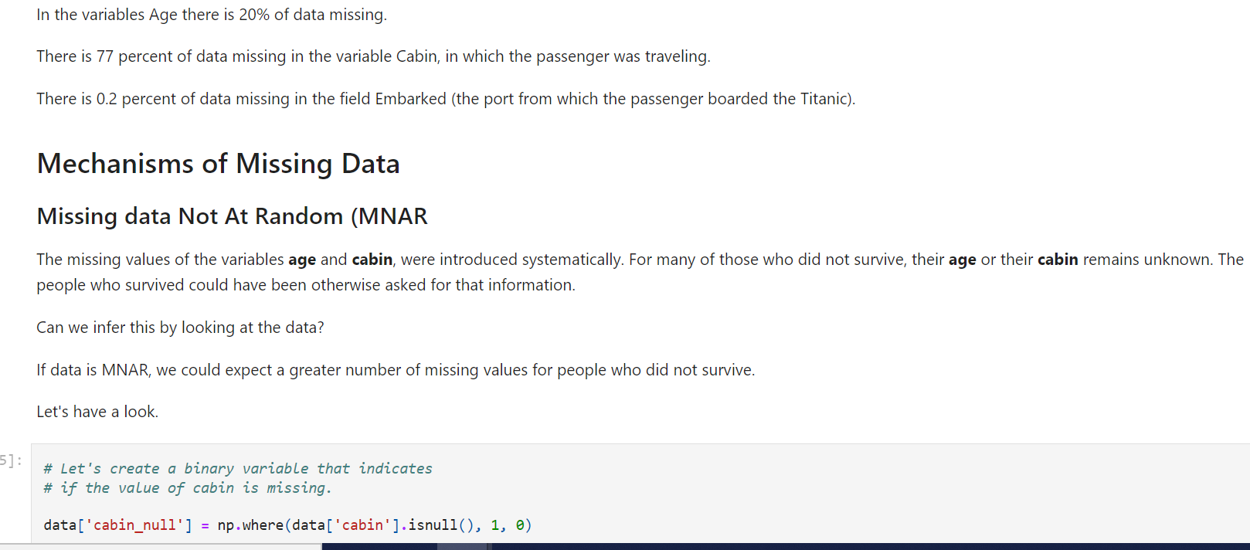

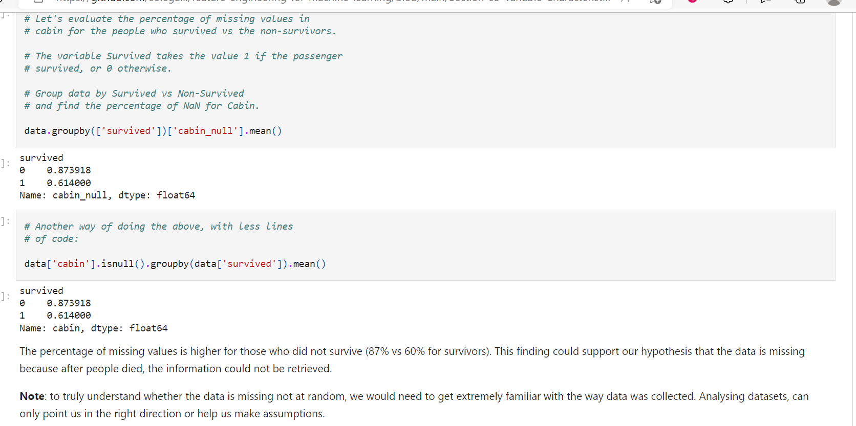

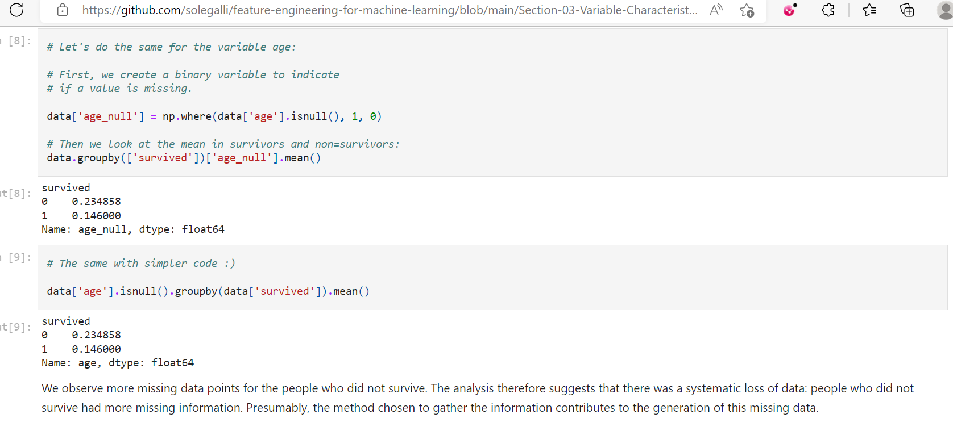

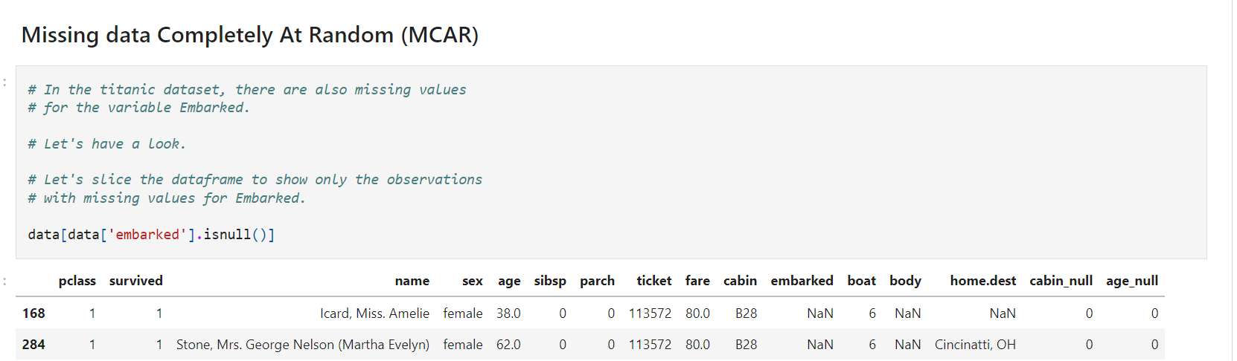

These 2 women were traveling together. Miss Icard was the maid of Mrs. Stone.

A priori, there does not seem to be an indication that the missing information in the variable "embarked" is dependent on any other variable, and the fact that these women survived means that they could have been asked for this information.

It is very likely the values were lost at the time of building the dataset.

If these values are MCAR, the likelihood of data missing for these two women is the same as the likelihood of data missing for any other person on the Titanic. Of course, this will be hard, if possible at all, to prove.

**Missing data at Random (MAR)**

We will use the financial dataset from the peer-to-peer lending company.

We will look at the variables "employment" and "years in employment", both declared by the borrowers at the time of applying for a loan.

In this example, data missing in employment are associated with data missing in time in employment.

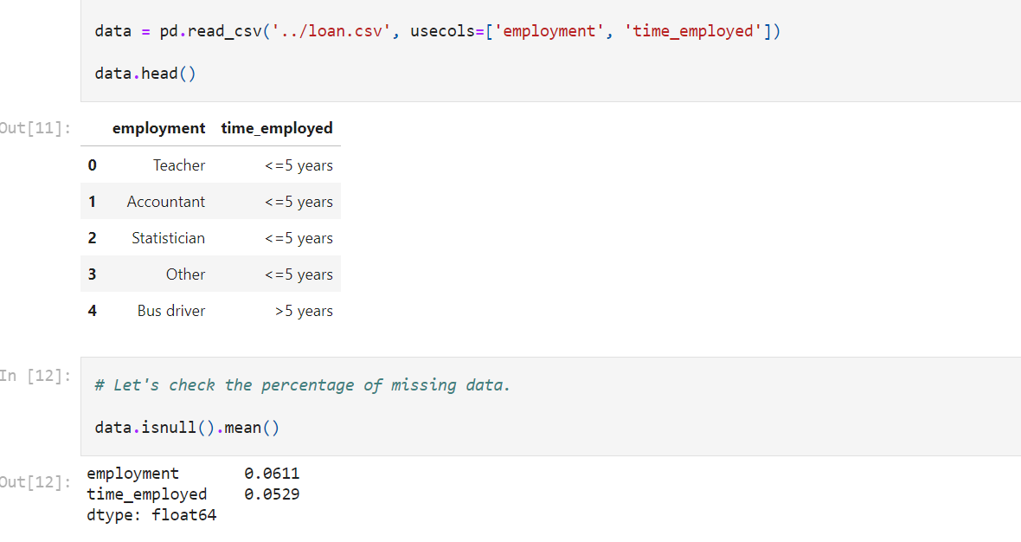

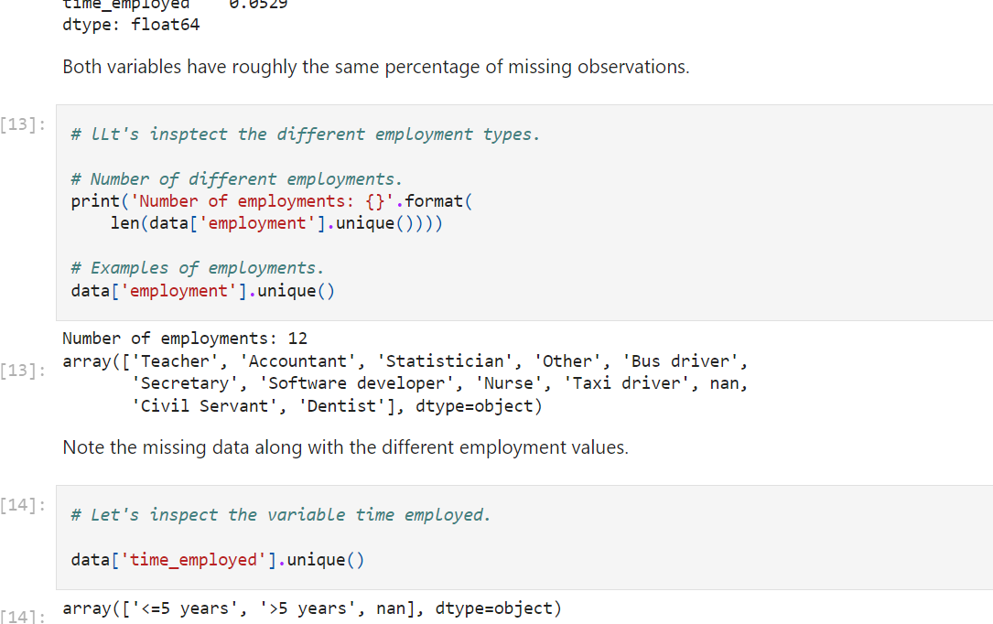

The customer can't enter a value for employment time if they are not employed. They could be students, retired, self-employed, or something else. Note how these 2 variables are related to each other.

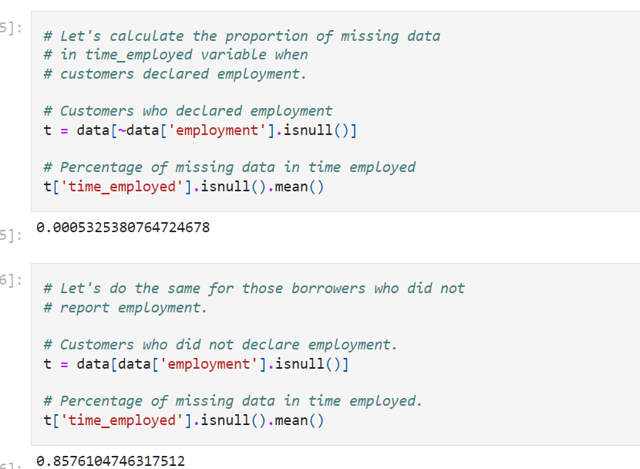

The number of borrowers who have reported occupation and have missing values in time_employed is minimal. Customers who did not report an occupation, on the other hand, mostly show missing values in the time_employed variable.

This further supports the hypothesis that the missing values in employment are related to the missing values in time_employed.

This is an example of MAR.

**That is all for this demonstration. I hope you enjoyed the notebook, and I'll see you in the next one.**

**Cardinality**

The values of a categorical variable are selected from a group of categories, also called **labels**. For example, in the variable ***gender* the categories are male and female,** whereas in the variable *city* the labels could be **London, Manchester, Brighton**, and so on.

Categorical variables can contain different numbers of categories. The variable **"gender**" contains **only 2 labels,** but a variable like "**city" or "postcode**" can contain **a huge number of labels.**

**The number of different labels is known as cardinality**

**. A high number of labels** within a variable is known as **high cardinality**.

**Is high cardinality a problem?**

High cardinality poses the following challenges:

* Variables with too many labels **tend to dominate** those with only a few labels, particularly in **decision tree-based** algorithms.
* High cardinality may **introduce noise.**
* **Some of the labels may only** be present in **the training data** set and **not in the test set**, so machine learning **algorithms may over-fit to the training set.**
* **Some labels may appear only** in the **test set**, leaving the **machine learning algorithms unable to perform a calculation** over the new (unseen) observation.

**Algorithms based on decision trees can be biased towards variables with high cardinality**.

Tree based – biased towards variables with high cardinality

Below is a demo about the effect of high cardinality on the performance of various machine learning algorithms.

**In this Demo:**

* Learn how to **quantify cardinality.**
* See examples of **high and low cardinality variables**.
* Understand the **effect of cardinality in train and test sets.**
* Evaluate the **effect of cardinality on machine learning model performance**.

We will use the Titanic dataset.

* To download the dataset, please refer to the **Datasets** lecture in **Section 1** of the course.

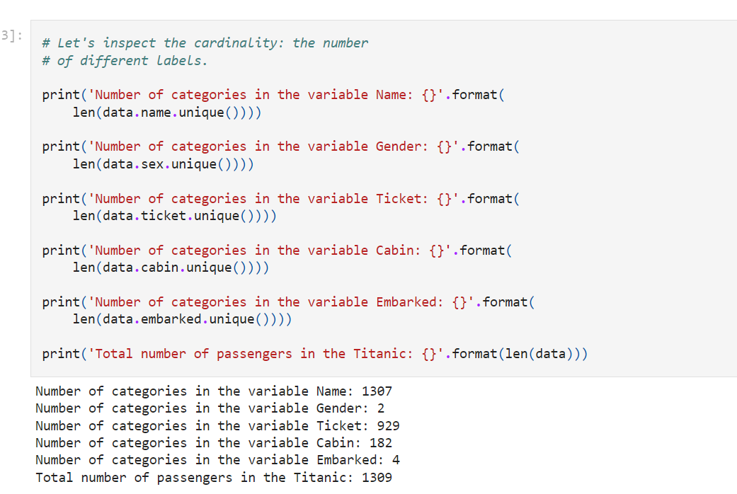

While the variable

**Sex contains only 2 categories** and the variable

**Embarked 4 (low cardinality),**

the **variables Ticket, Name, and Cabin, as expected,** contain a **huge number of different labels (high cardinality).**

To demonstrate the effect of high cardinality on train and test sets and on machine learning performance, I will work with the variable cabin. I will create a new variable with reduced cardinality.

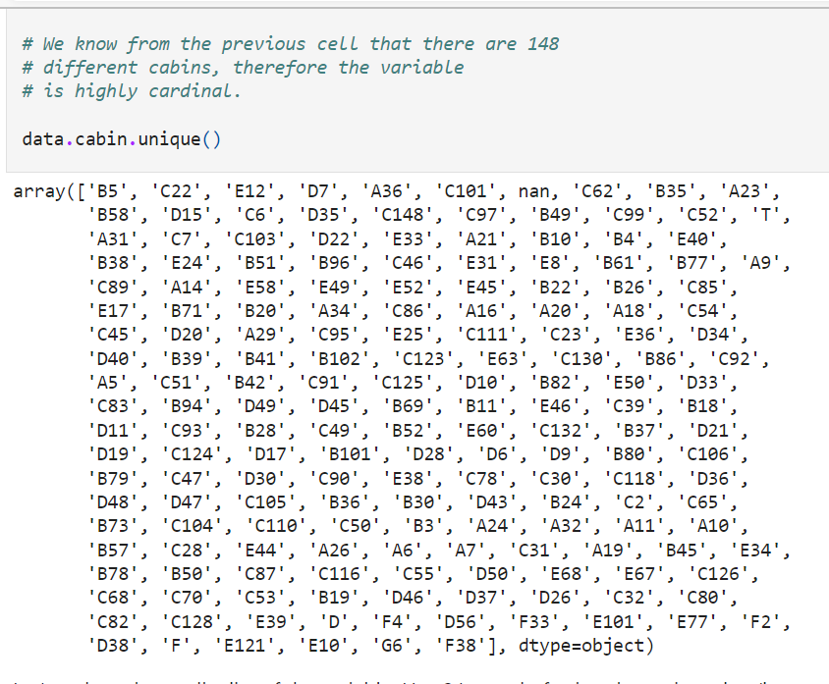

Let's reduce the cardinality of the variable. How? Instead of using the entire value (letter + number), I will only use the first letter.

Instead of letter and number

Use only letter

**Rationale**: the first letter indicates the deck on which the cabin was located, indicating both social class status and proximity to the Titanic's surface. Both are known to improve the probability of survival.

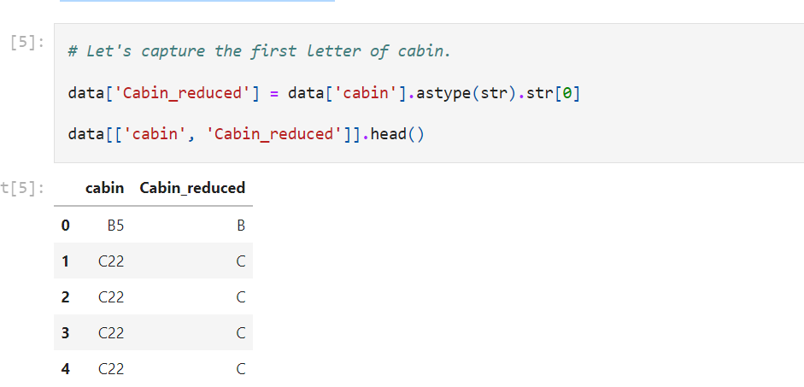

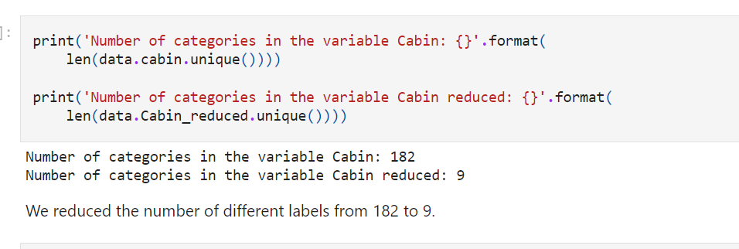

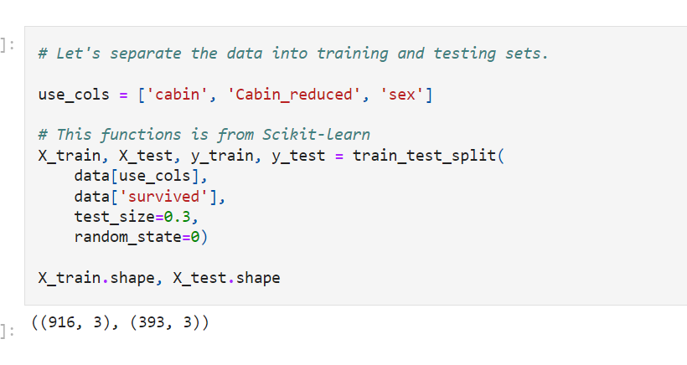

**Uneven distribution of categories**

When a variable is **highly cardinal**, **some categories appear only on the training set**, **and others only on the testing set.**

If present only in the training set, they **may cause over-fitting**.

If present only on the testing set, the **machine learning model will not know how to handle them**, as they **were not seen during training.**

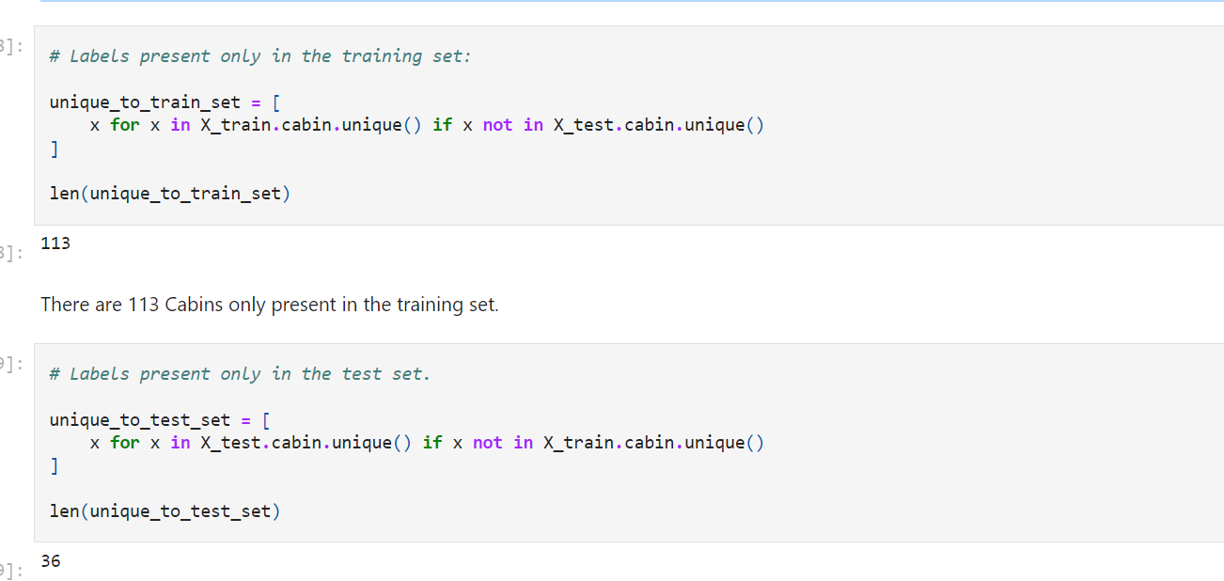

Variables with high cardinality have categories present either only in the training set, or only in the testing set. This will cause problems at the time of training (over-fitting) and scoring of new data (how will the model deal with unseen categories?).

This problem can be mitigated by reducing the cardinality of the variable. Let's do that.

Solution ?

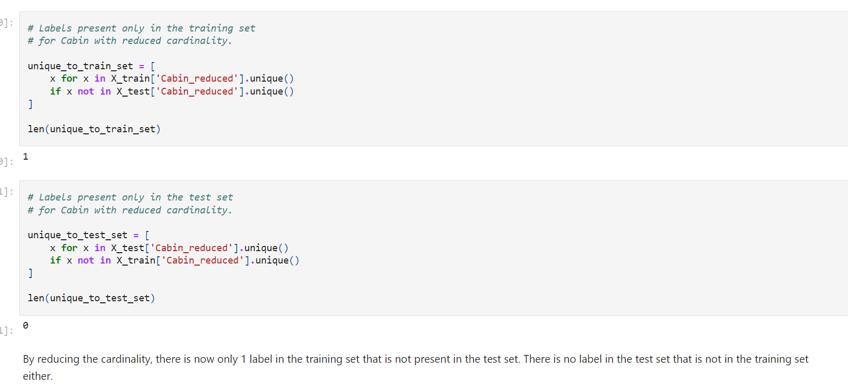

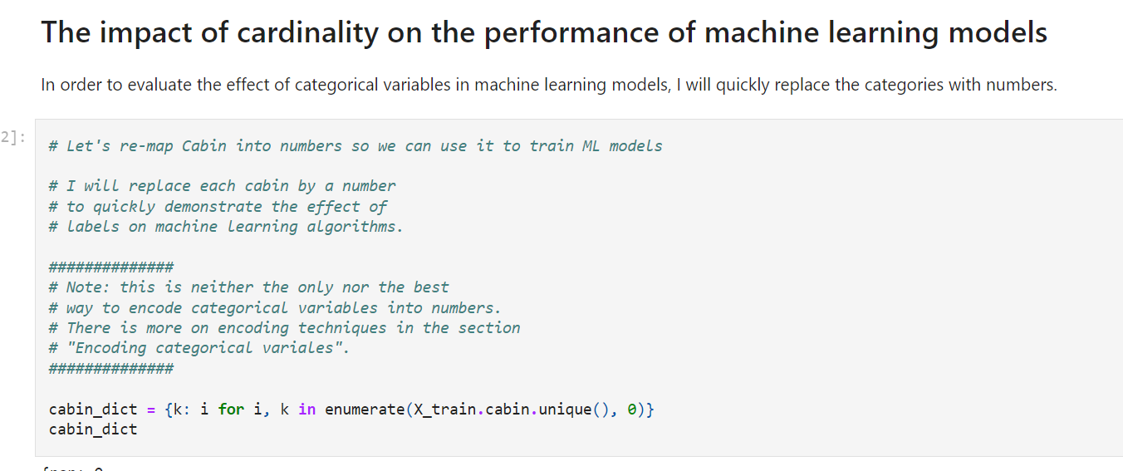

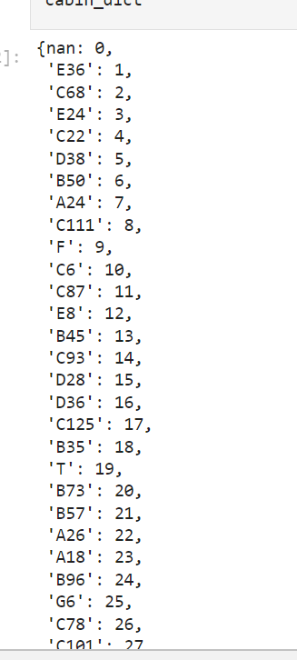

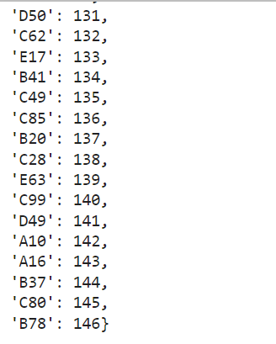

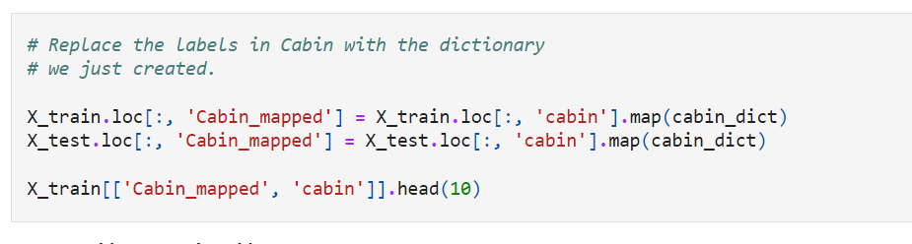

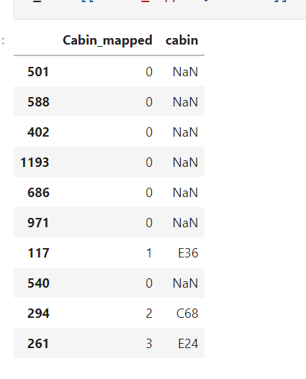

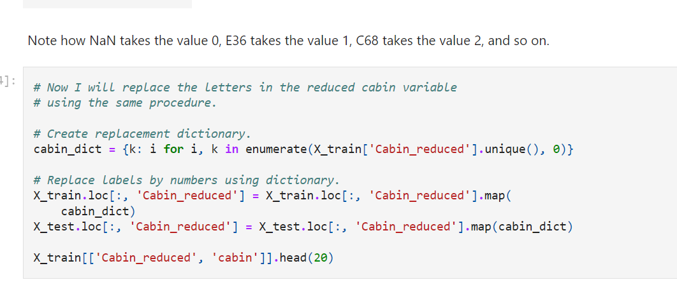

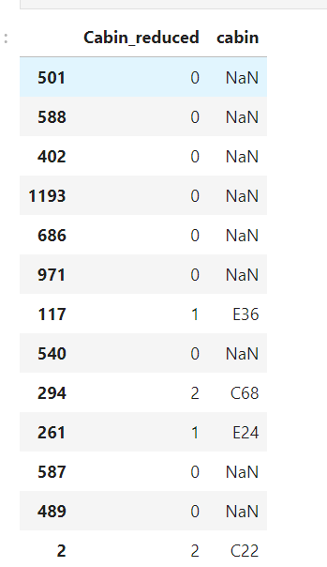



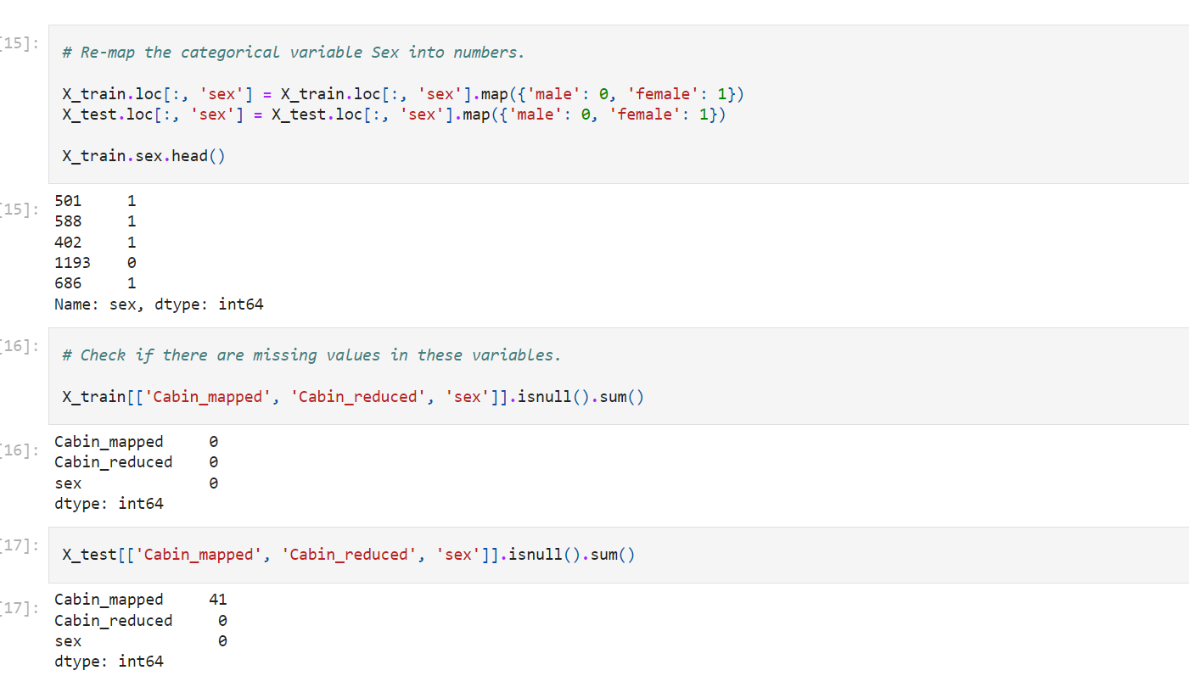

In the test set, there are now 41 missing values for the highly cardinal variable. These were introduced when encoding the categories into numbers.

How?

Many **categories exist only in the test set**. Thus, when we created our encoding dictionary using only the train set, we did not generate a number to replace those labels **present only in the test set**. As a consequence**, they were encoded as NaN**. We will see in future notebooks how to tackle this problem. For now, I will fill in those missing values with 0.

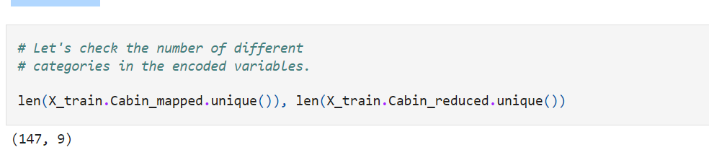

From the above we note immediately that from the **original 182 cabins** in the dataset, only **147 are present in the training set.** We also see **how we reduced the number of different categories to just 9 in our previous step.**

Let's go ahead and evaluate the effect of cardinality in machine learning algorithms.

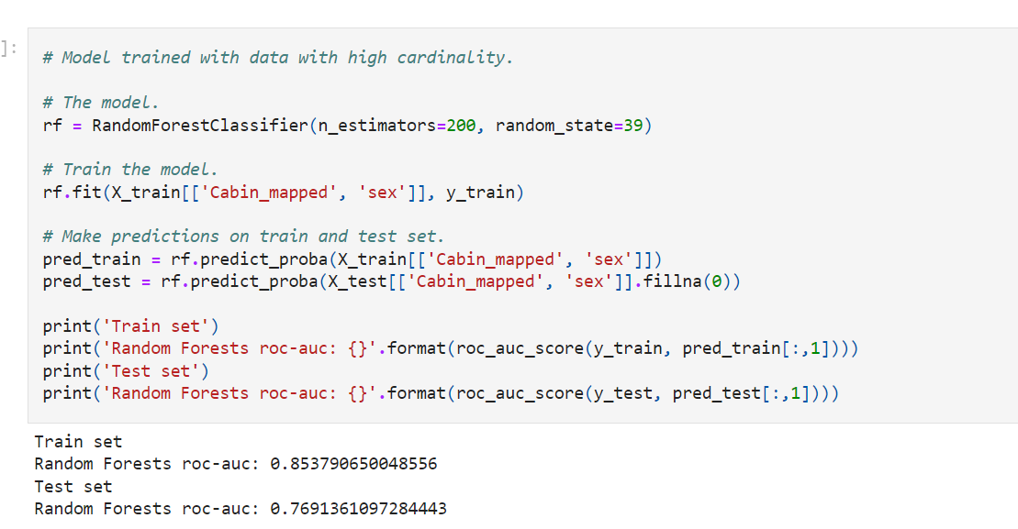

The performance of the Random Forests on the training set is **quite superior to its performance on the test set.** This indicates that the **model is over-fitting**, which means that it does a great job of predicting the outcome on the dataset it was trained on, but it lacks the **power to generalise the prediction to unseen data.**

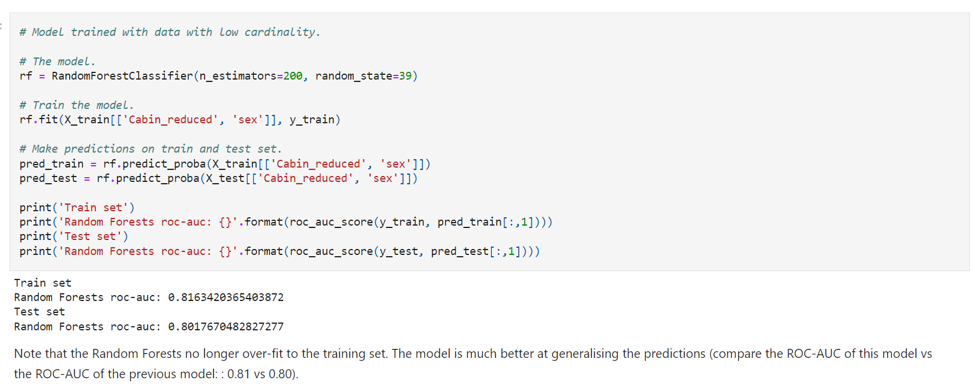

Note that the Random Forests **no longer over-fit to the training set**. The model **is much better at generalising the predictions** (compare the ROC-AUC of this model vs the ROC-AUC of the previous model: : 0.81 vs 0.80).

**I would like to point out, that likely we can overcome the effect of high cardinality by adjusting the hyper-parameters of the random forests. That goes beyond the scope of this course. Here, I want to show you that given a model with identical hyper-parameters, high cardinality may cause the model to over-fit**.

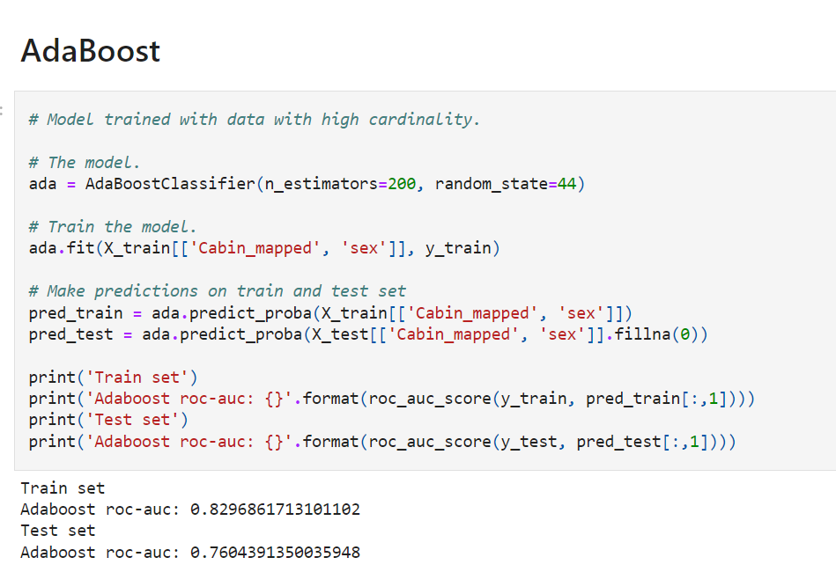

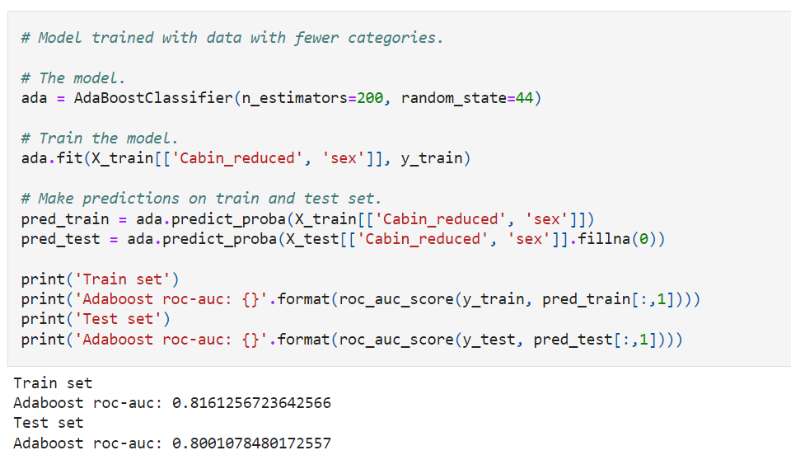

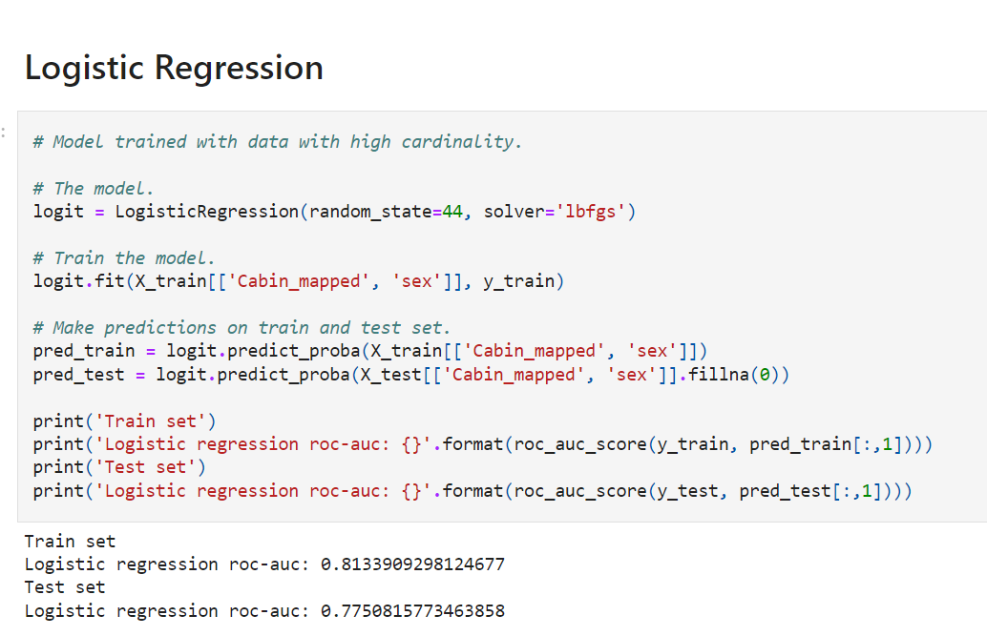

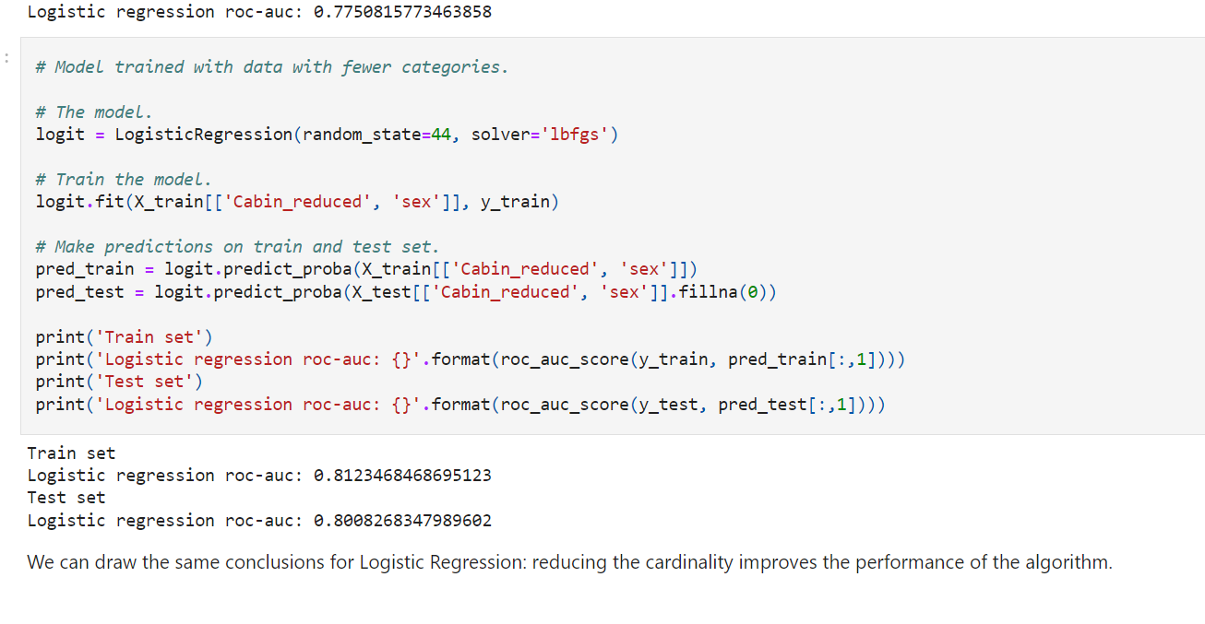

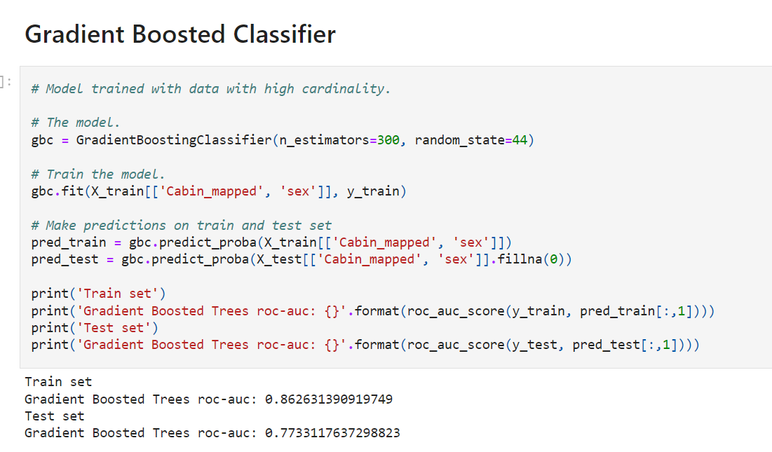

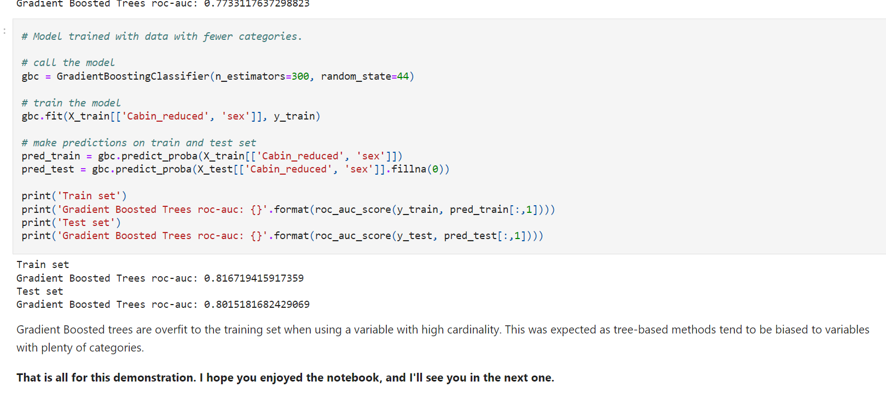

**Cordiality :**

**The values of categorical selected from group of categories(called labels)**

**Number of different lables is known as cardinality**

**High number of lables leads to high cardinality**

**Gender =2**

**Pin code = many**

**Drawbacks:**

**Uneven distribution of lables between train and test**

**Overfit- tree based**

**Categories- numbers (encoding)**

**Verfit-train**

**Test – doent know what to do as they didn’t encounter intraining**

**(operationalization problem)**

**Big number of labels in a variable may cause – noise**

**Rare Labels**

**Categorical variables** are those whose values are **selected from a group of categories,** also called labels.

**Labels - different frequencies**.

Some categories appear **a lot in the dataset**, some others appear only in **a small number** of observations.

For example, in a dataset with information about loan applicants where one of the variables is "city" where the applicant lives, **cities like "New York**" may appear a lot in the data because New York has a huge population, whereas **smaller towns like "Leavenworth**" will appear only on a few occasions (population ~2000 people), because the population there is very small. **A borrower is more likely to live in New York** than in any other city because it has a bigger population.

Categorical variables may contain a **few dominant labels** that account for **the majority of the observations** and a **large number of labels** that **appear only rarely**.

**Is label frequency a problem?**

Rare values **can add a lot of information or none at all**.

For example, consider **a stockholder meeting** where **each person can vote** in proportion to their number of shares.

One of the **shareholders owns 50% of the stock**, and the other **999 shareholders own the remaining 50%.** The **outcome of the vote is largely influenced by the shareholder who holds the majority of the stock**.

The remaining shareholders may have an impact collectively, but they **have almost no impact individually.**

The same occurs in real-life datasets. **The label that is over-represented in the dataset** tends to **dominate the outcome**, and those that are under-represented may have **no impact individually, but could have an impact collectively.**

**Individually they may not have impact**

**But collectively they have**

More specifically,

* **Rare categories** can cause **over-fitting,** particularly **in tree-based methods**.
* Infrequent labels may **add noise**, which could cause **over-fitting.**
* Rare labels may be **present only in training set**, therefore causing **over-fitting.**
* Rare labels may appear only in **the test set**. Thus, the ML model **will not know how to evaluate it.**
* **Imp – during fraud**

**Note** **Sometimes rare values, are indeed important**. For example, if we are building a model to **predict fraudulent loan applications**, which are **by nature rare**, then a **rare value in a certain variable, may be indeed very predictive.** This **rare value could be telling us that the observation is most likely a fraudulent application,** and therefore we should not to ignore it.

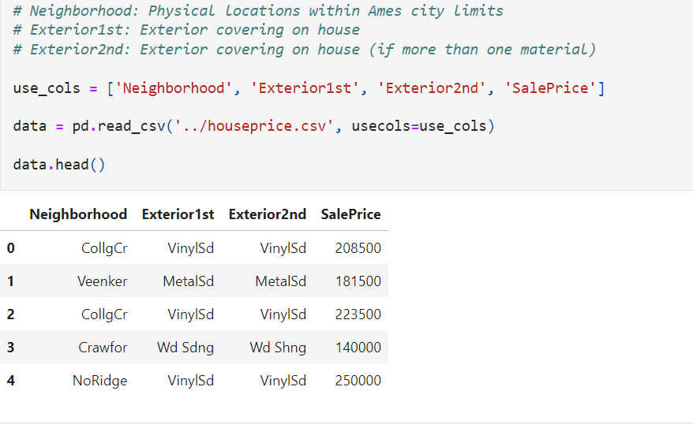

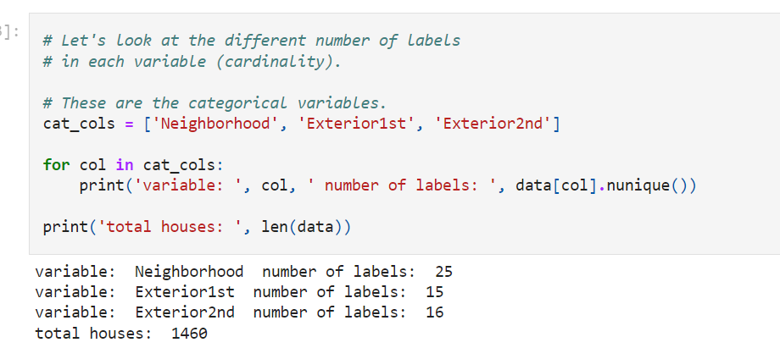

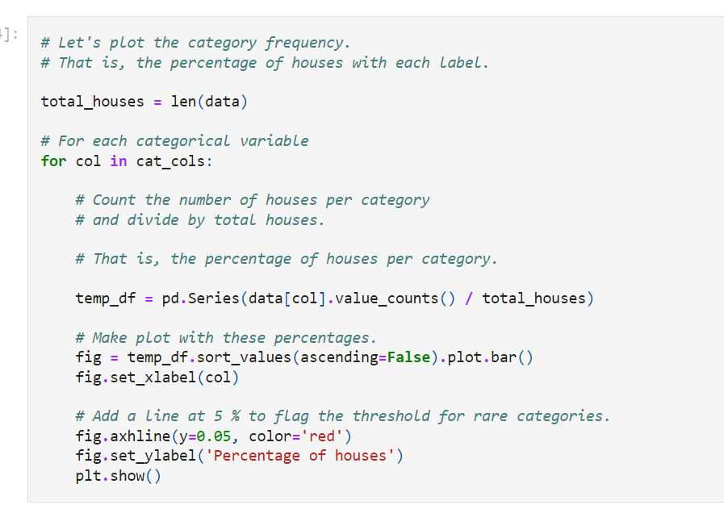

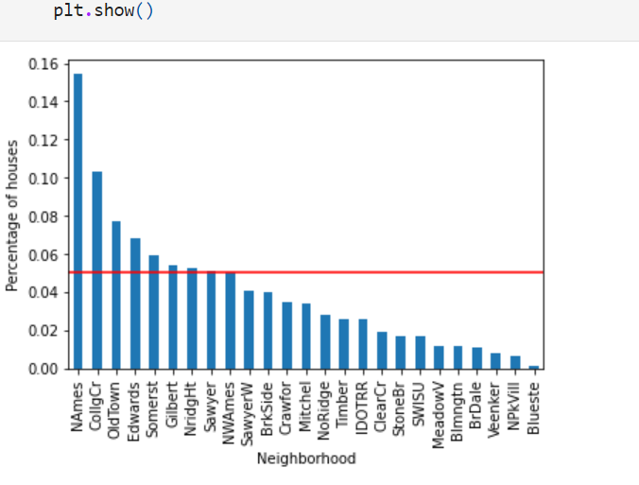

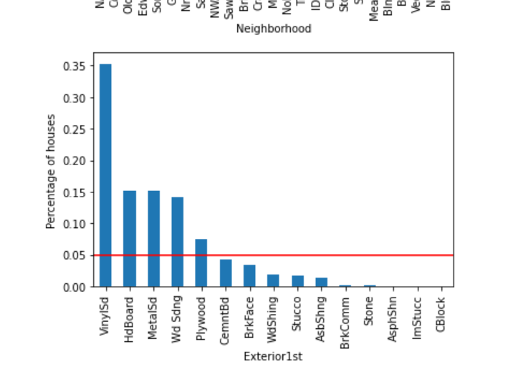

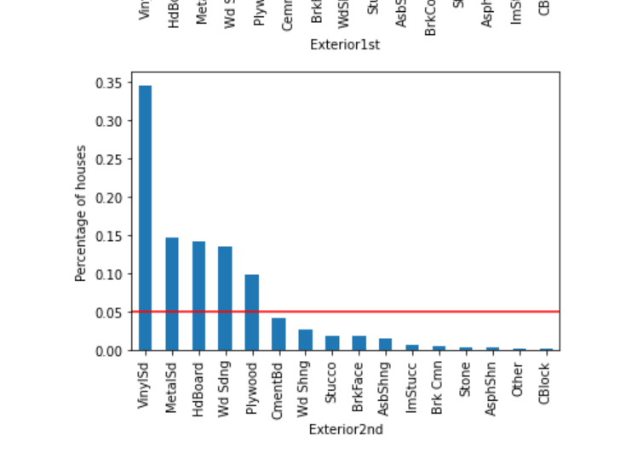

Some labels appear in more than 10% of the houses and many appear in less than 10% or even 5% of the houses. These are infrequent labels or **Rare Values** and could cause over-fitting.

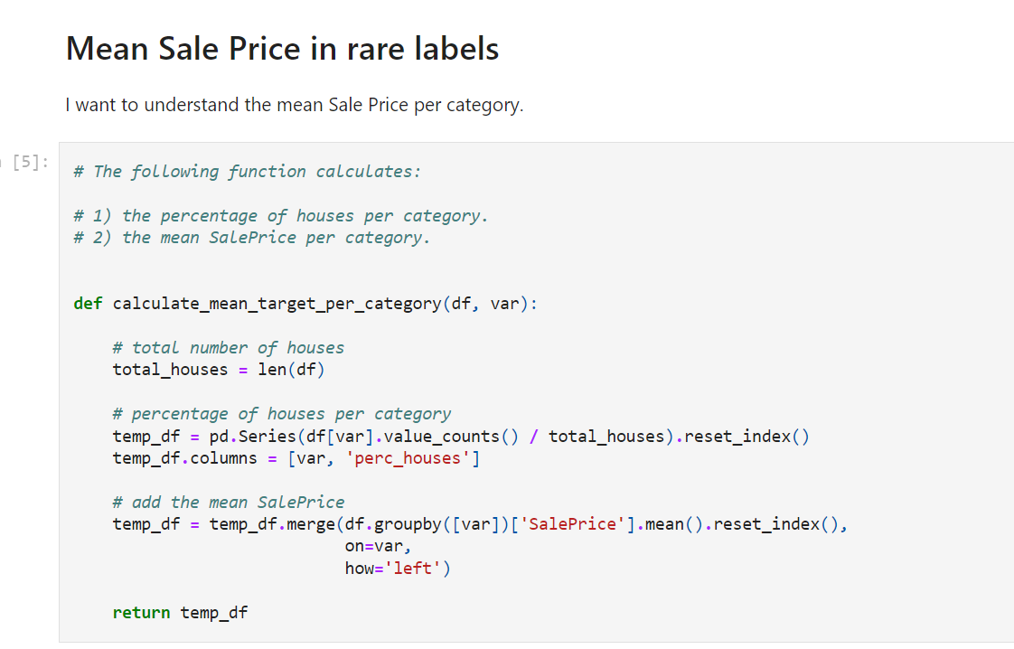

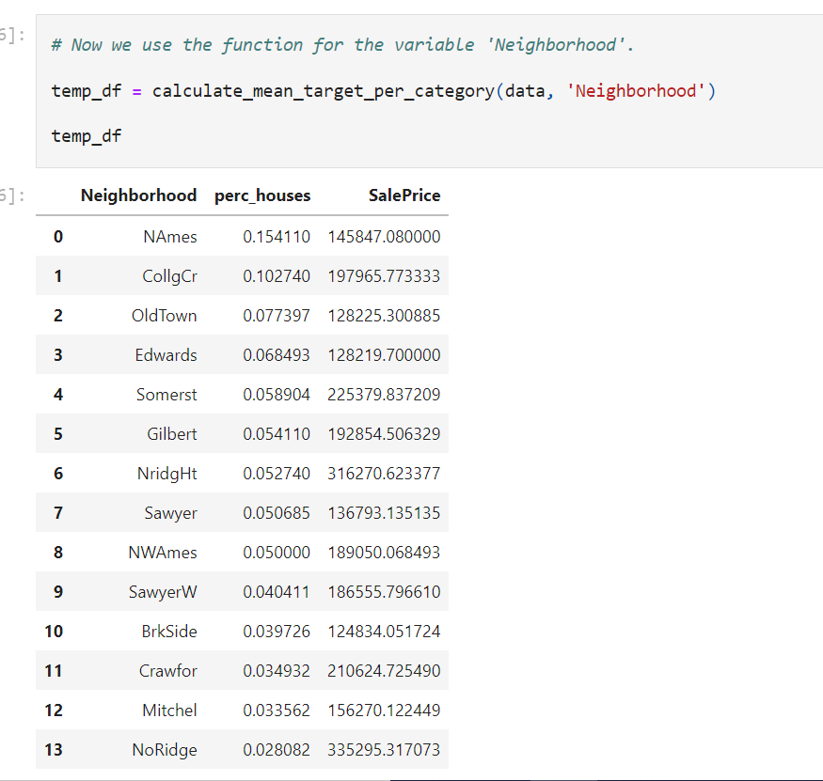

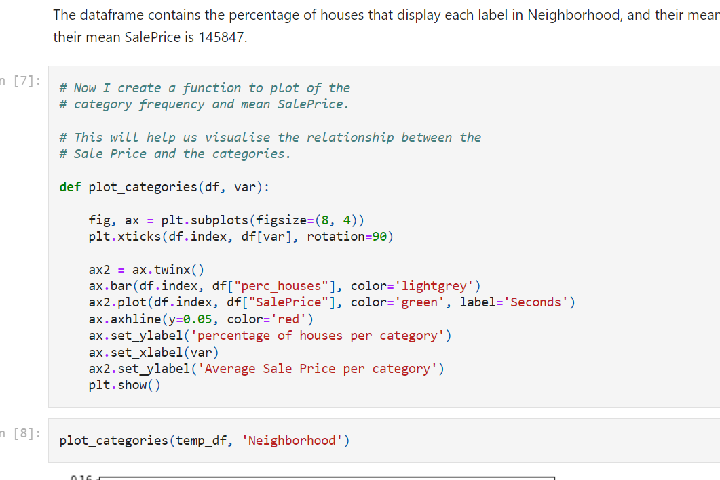

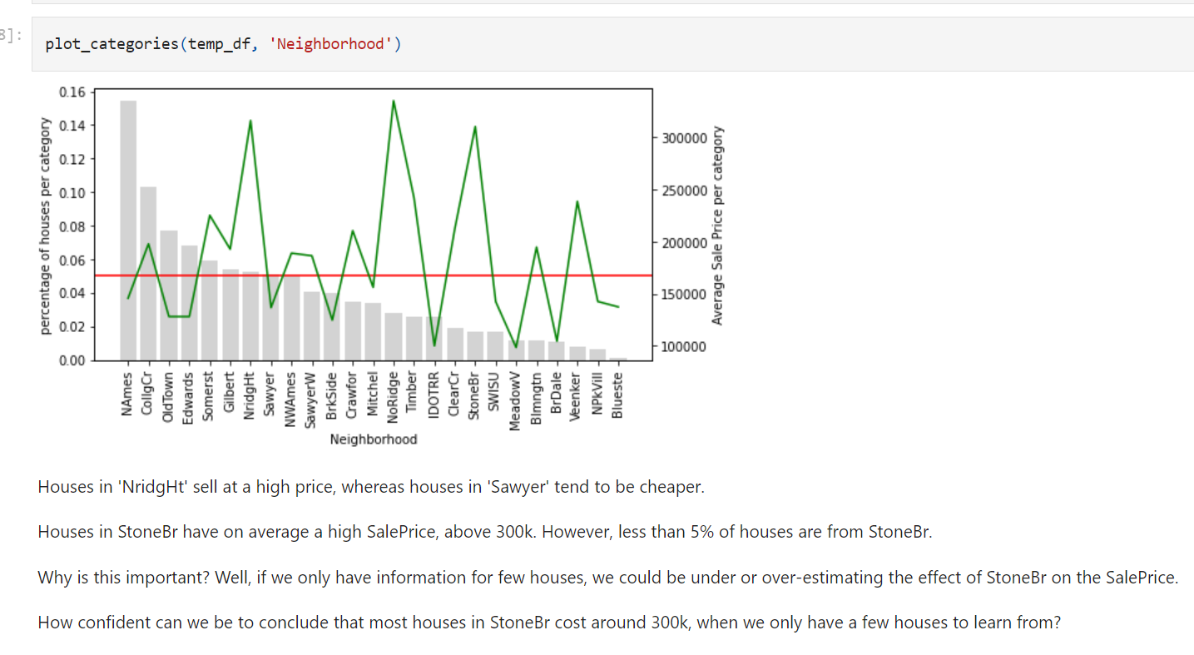

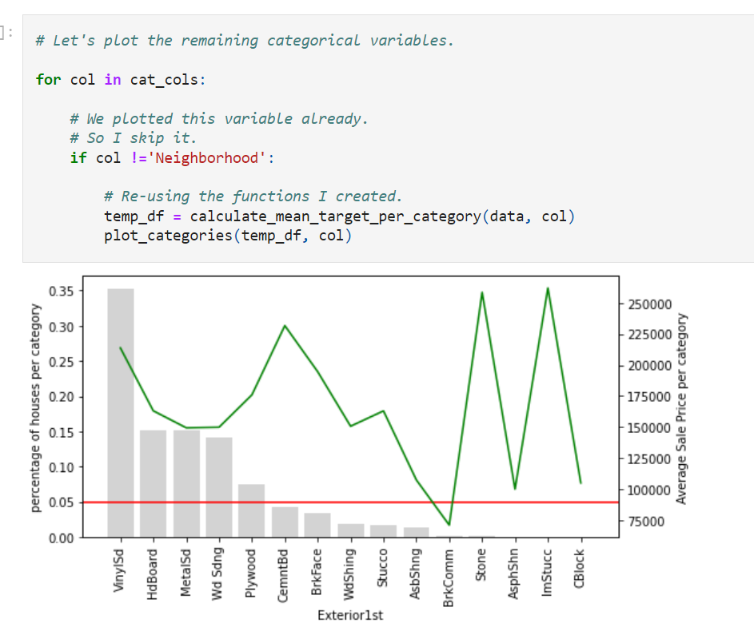

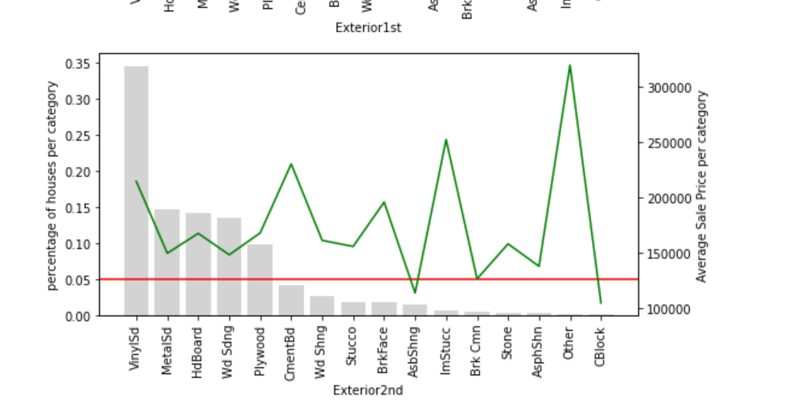

**Grouping rare labels**

A common way of handling rare values is to group them under an umbrella category called 'Rare' or 'Other'. Like this, we are able to understand their "collective" impact on the target.

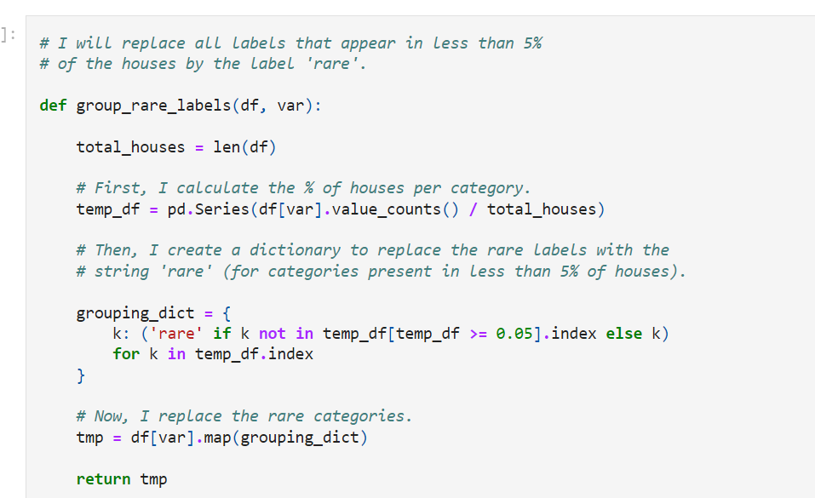

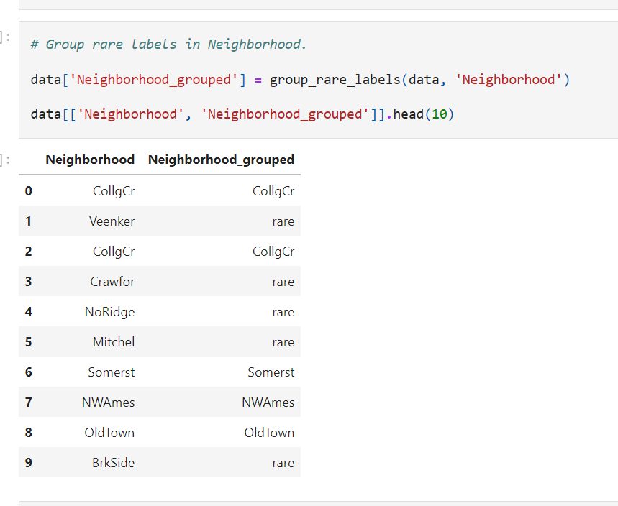

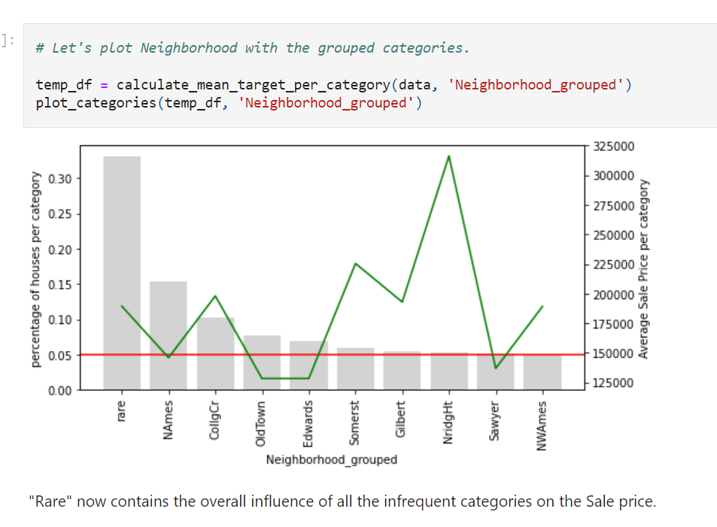

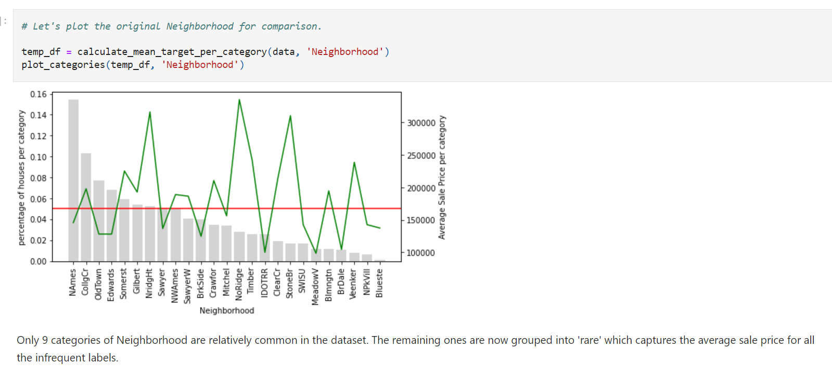

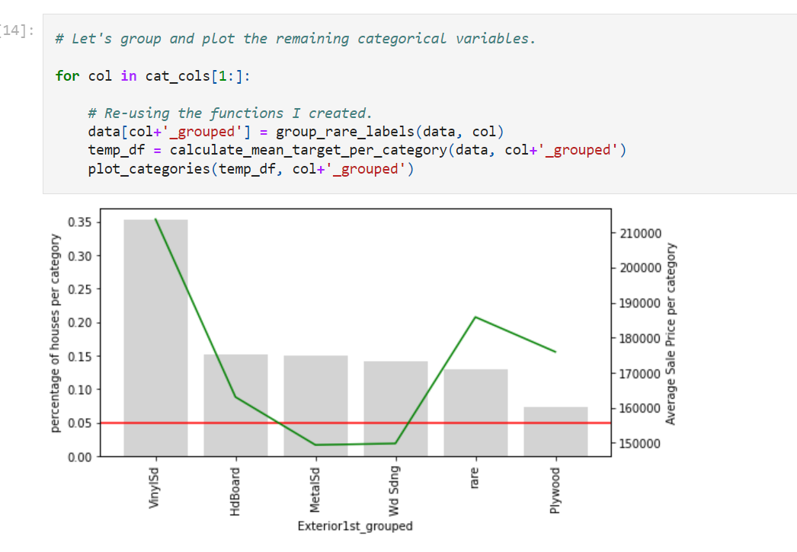

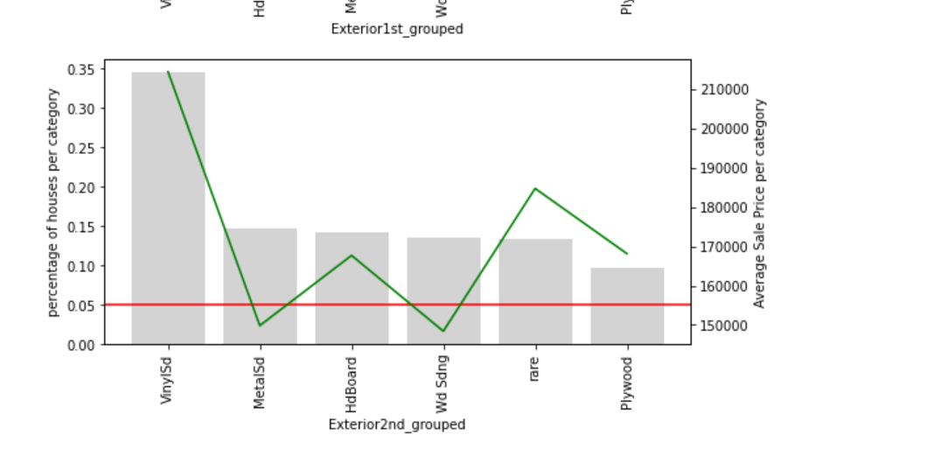

**Uneven distribution between train and test sets**

Similarly to highly cardinal variables, rare labels often appear only on the training set or only on the testing set. If only in the training set, they may lead to over-fitting. If only in the testing set, machine learning models will not know how to handle them because they were not seen during training.

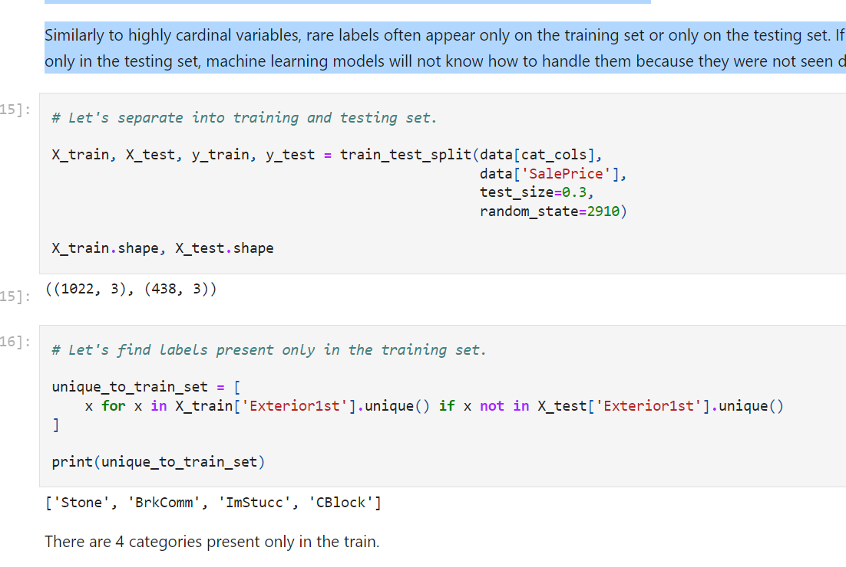

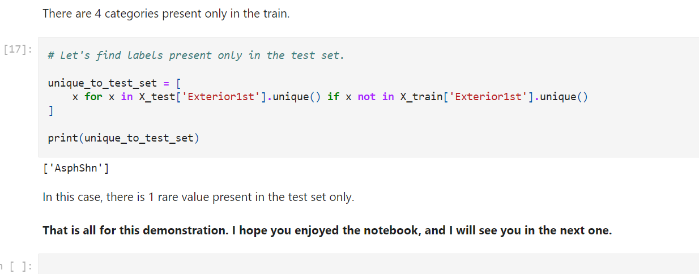

**Rare lables:**

**Appear very tiny proportion in a variable**

**Rare lables: hard to understand effect of these lables on outcome**

**Linear Model Assumptions**

Linear regression assumptions are:

* **Linearity**: The mean values of the outcome variable for each increment of the predictor(s) lie along a straight line. In other words, there is a linear relationship between predictors and target.
* **No perfect multicollinearity**: There should be no perfect linear relationship between two or more of the predictors.
* **Normally distributed errors**: the residuals are random and normally distributed with a mean of 0.
* **Homoscedasticity**: At each level of the predictor variable(s), the variance of the residual terms should be constant.

Examples of linear models are:

* Linear and Logistic Regression
* Linear Discriminant Analysis (LDA)

**Failure to meet one or more of the model assumptions could end up in a poor model performance**.

If the assumptions are not met, we can:

* **Use a different, no-linear model to predict the outcome** from the variables.
* **Transform the input variables** so that they meet the assumptions.

**Performance of a linear model**

**To determine if a linear model fits the data well**,?

**we evaluate the residuals**.

The residuals should have a **normal distribution** with the **mean centered at zero**,

and should **be homoscedastic**.

If this is true, we can be fairly confident that the model is doing a good job.

The **normal distribution** can be assessed by **Q-Q plots.**

**Homoscedasticity** can be assessed by **residual plots.**

We can also examine if there is a **linear relationship between the predictors and the target** with **scatter-plots and residuals plots,** and assess **multi-colinearity with correlation matrices.**

**When model assumptions are not met**

Sometimes we can transform variables so that they meet the model assumptions. We normally do one of two things:

* **Mathematical transformation of the variables**
* **Discretisation**

**I will cover mathematical transformations and discretisation in later sections of the course**.

**In this demo...**

We will:

* Train a linear model to predict a target from 3 predictor variables
* **Evaluate if the model is accurate** by **examining the residuals**
* Determine if the **residuals are normally distributed**
* **Evaluate homoscedasticity**
* **Transform the data** and see how this improves model performance
* **Examine correlation and linear relationships between variables and target**

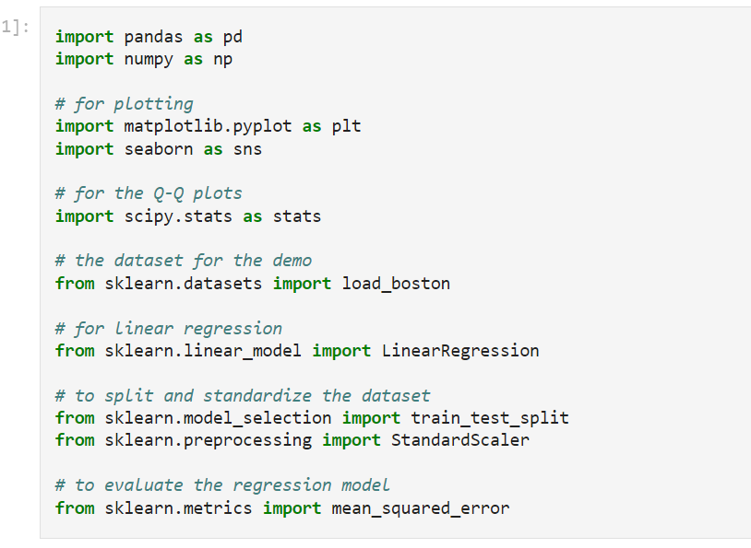

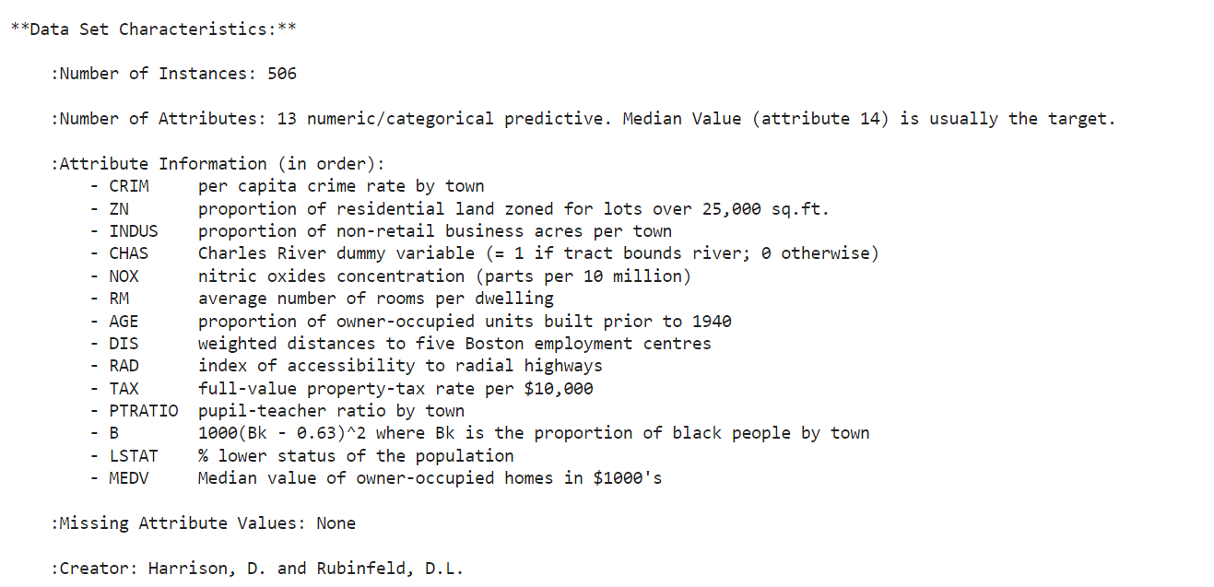

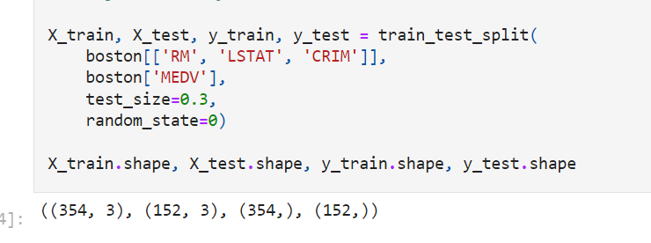

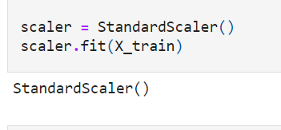

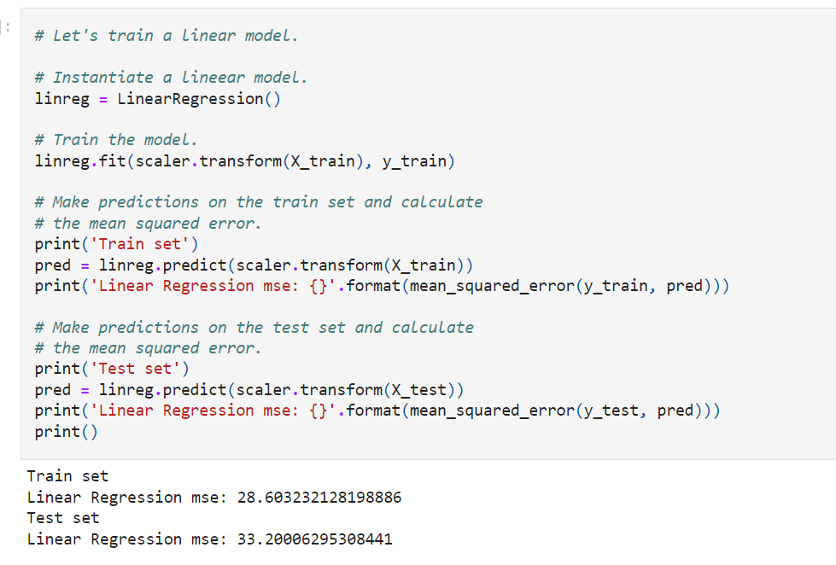

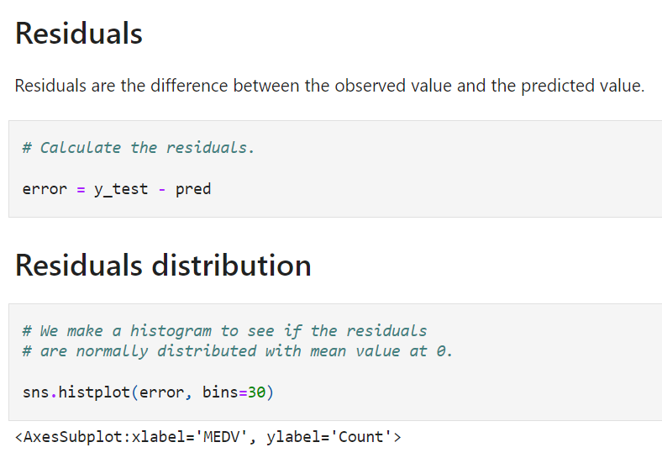

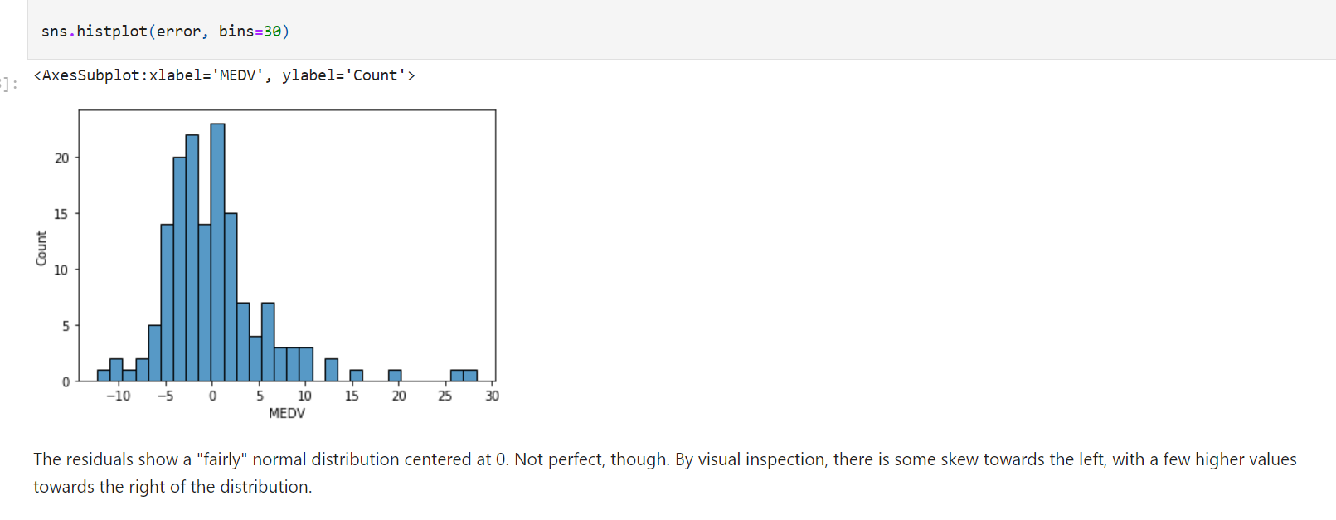

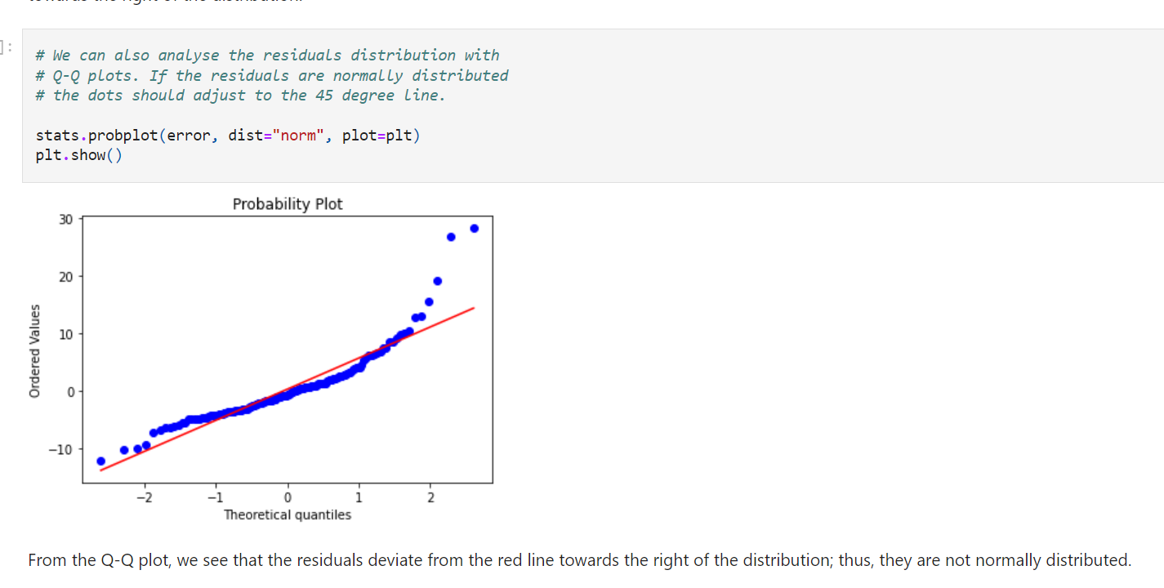

**Homoscedasticity**

Homoscedasticity implies that the **variance of the residual terms should be constant** at each level of the predictor variable(s).

So **we need to plot the residuals against the variables.**

Homoscedasticity, also known as **homogeneity of variance**, describes a situation in which the **error term (that is, the "noise" in the relationship between the independent variables and the target)** is the **same across all values of the independent variables.**

The way to identify if the variables are homoscedastic, is to make a **linear model with all the independent variables involved,** calculate the **residual**s,

**and plot** the **residuals vs. each of the independent variables**. If the distribution of the residuals is **homogeneous across the variable values**, then the variables are homoscedastic.

There are other tests for homoscedasticity:

* **Residuals plot**
* **Levene’s test**
* **Barlett’s test**
* **Goldfeld-Quandt Test**

But those escape the scope of this course. So for this demo, I will focus on residual plot analysis.

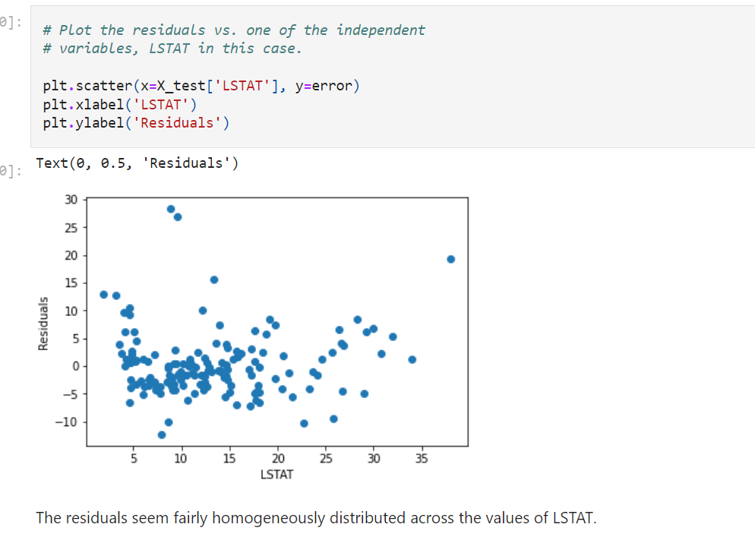

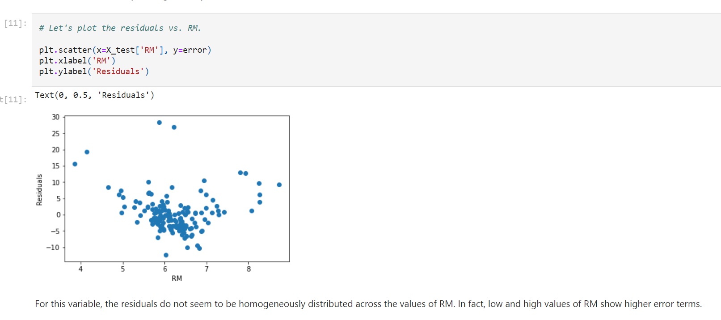

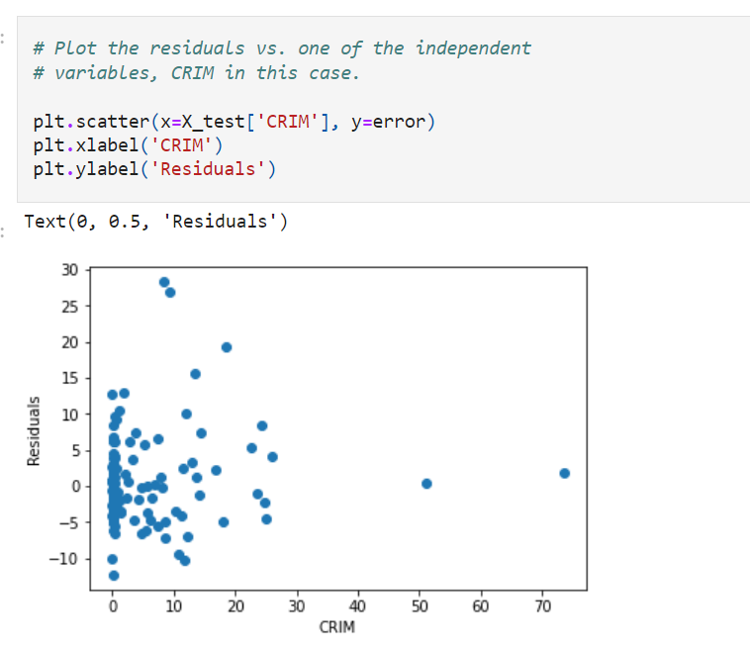



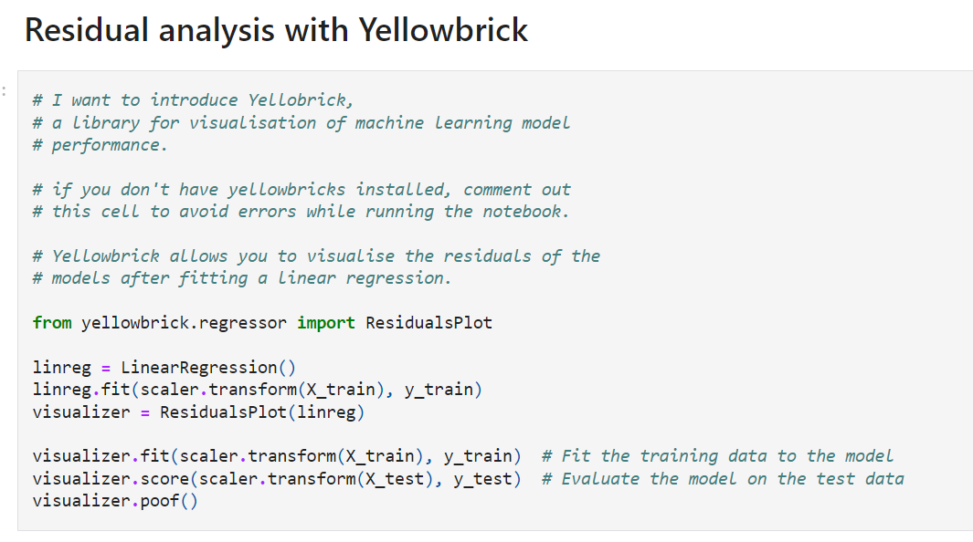

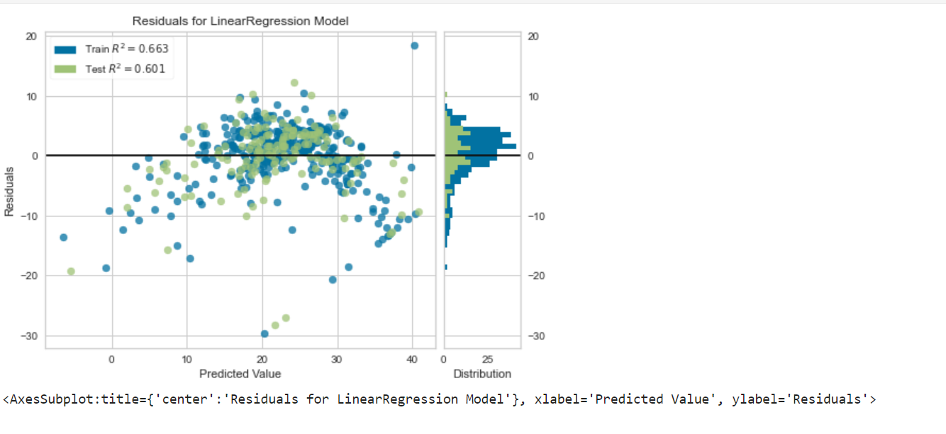

On the right, we see the **distribution of the residuals in the train and test sets.** **The residuals are not centered at 0.**

On the left, we see the **residuals vs. the predictions**. The residuals' **variance is not constant**, i.e., they are **not homoscedastic**.

Towards **the extremes of the prediction values,** the model is **under-estimating the outcome** (most residuals are negative). On the contrary, **towards the center of the prediction values**, the **model is over-estimating the outcome.**

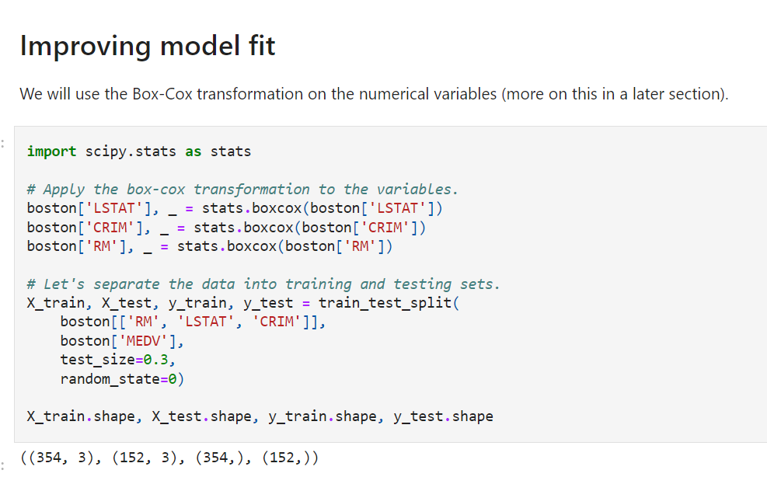

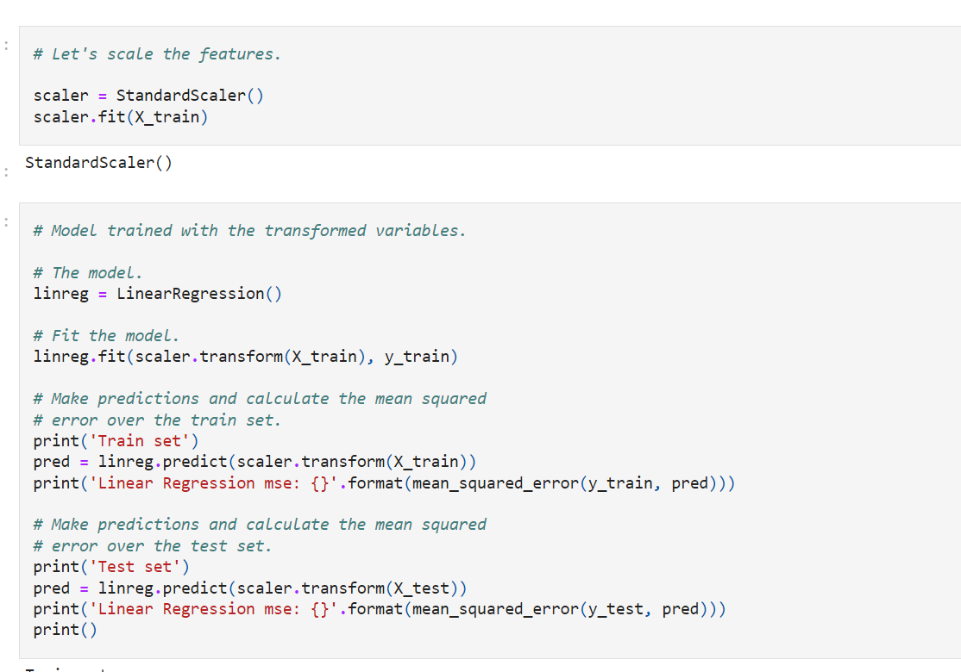

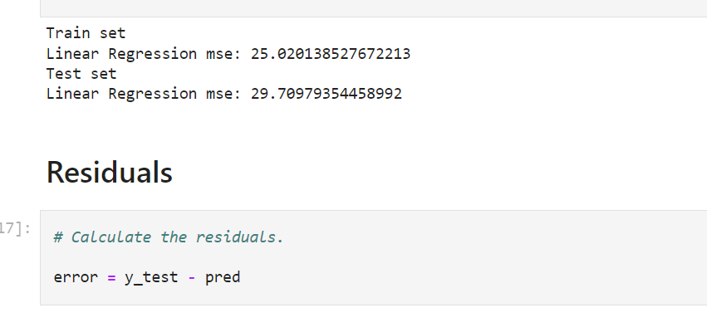

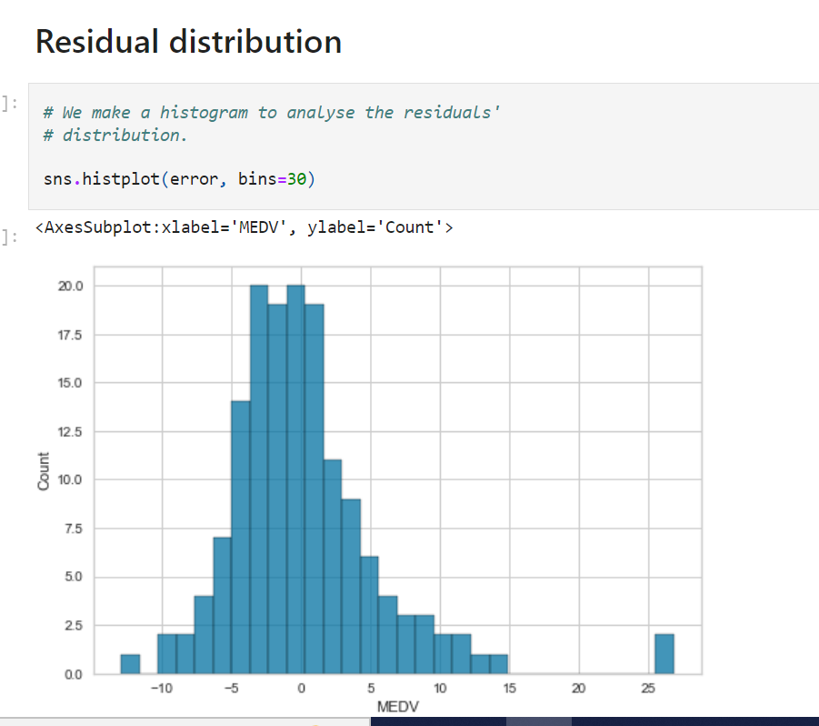

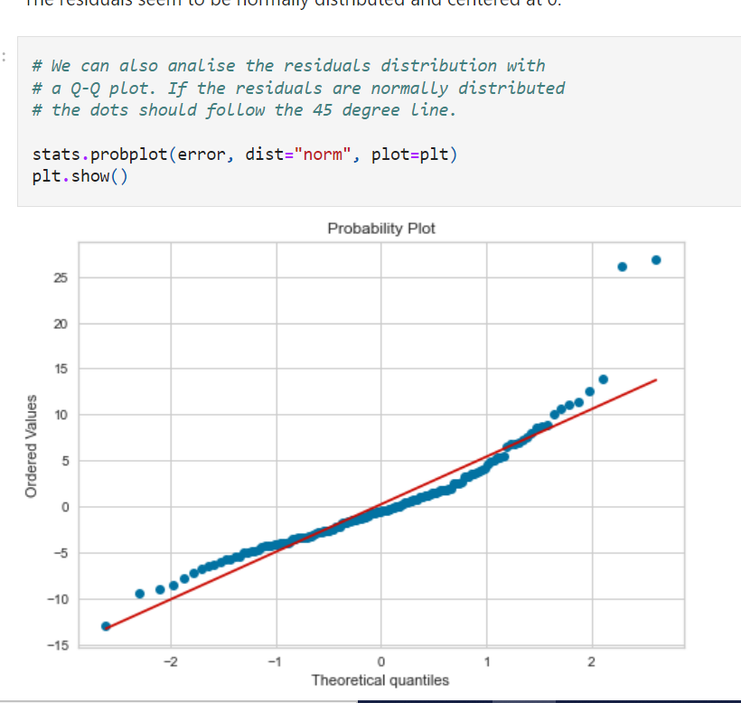

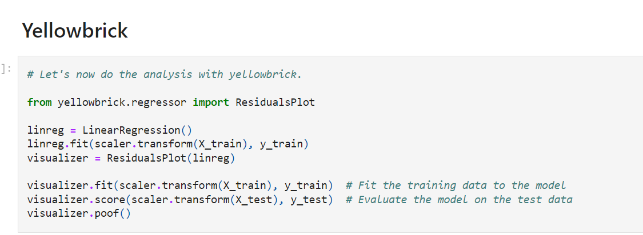

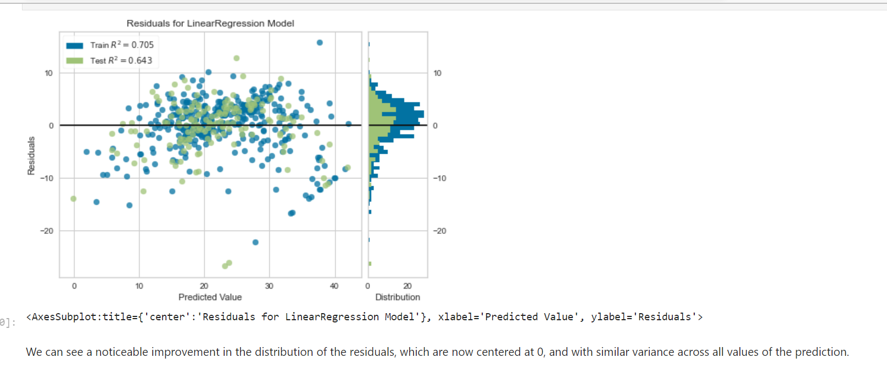

**Other model assumptions**

To understand the relationships between

**predictor variables and the outcome**, **and**

**predictor variables with themselves,** we can evaluate **the linear relationships and co-linearity**.

First, I will show how the plots should look like using a toy dataframe with a variable that is linearly related to the target.

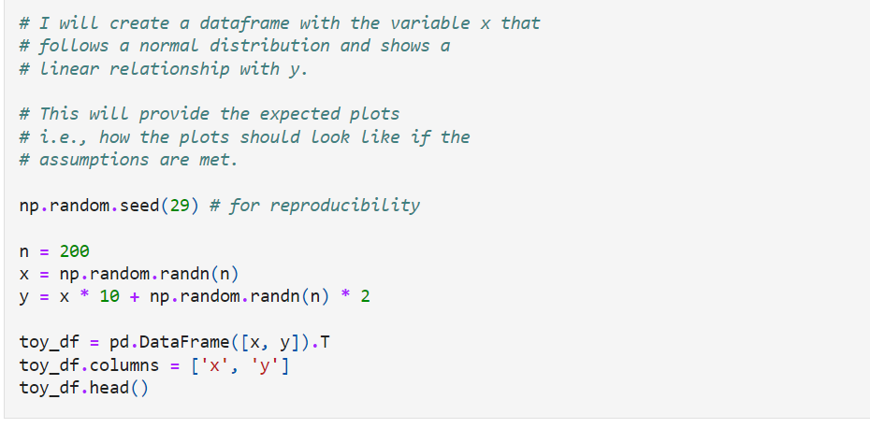

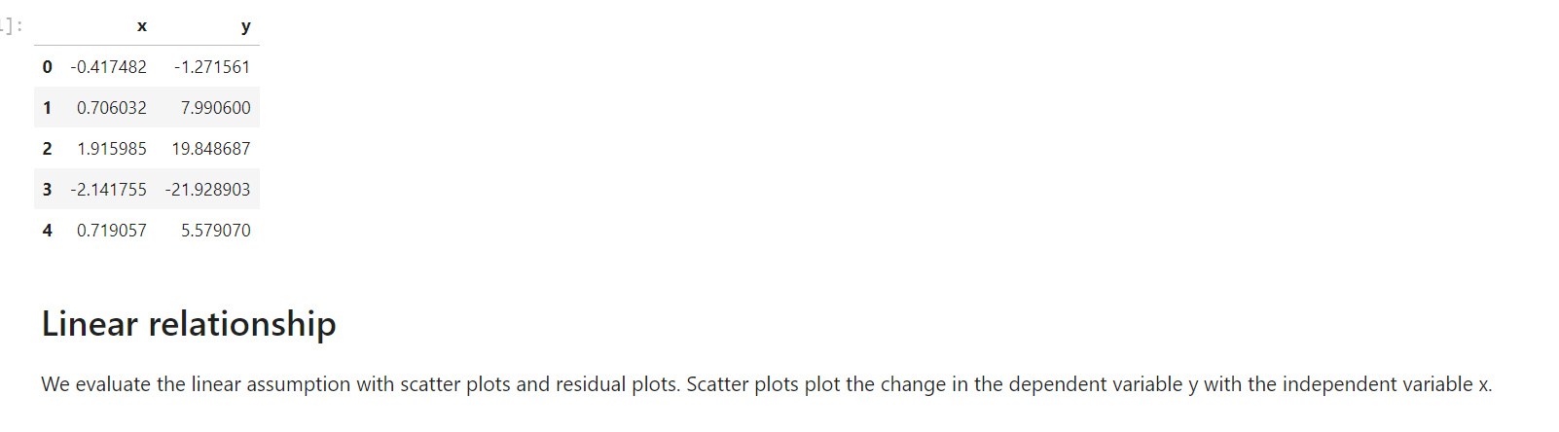

**Scatter plot**

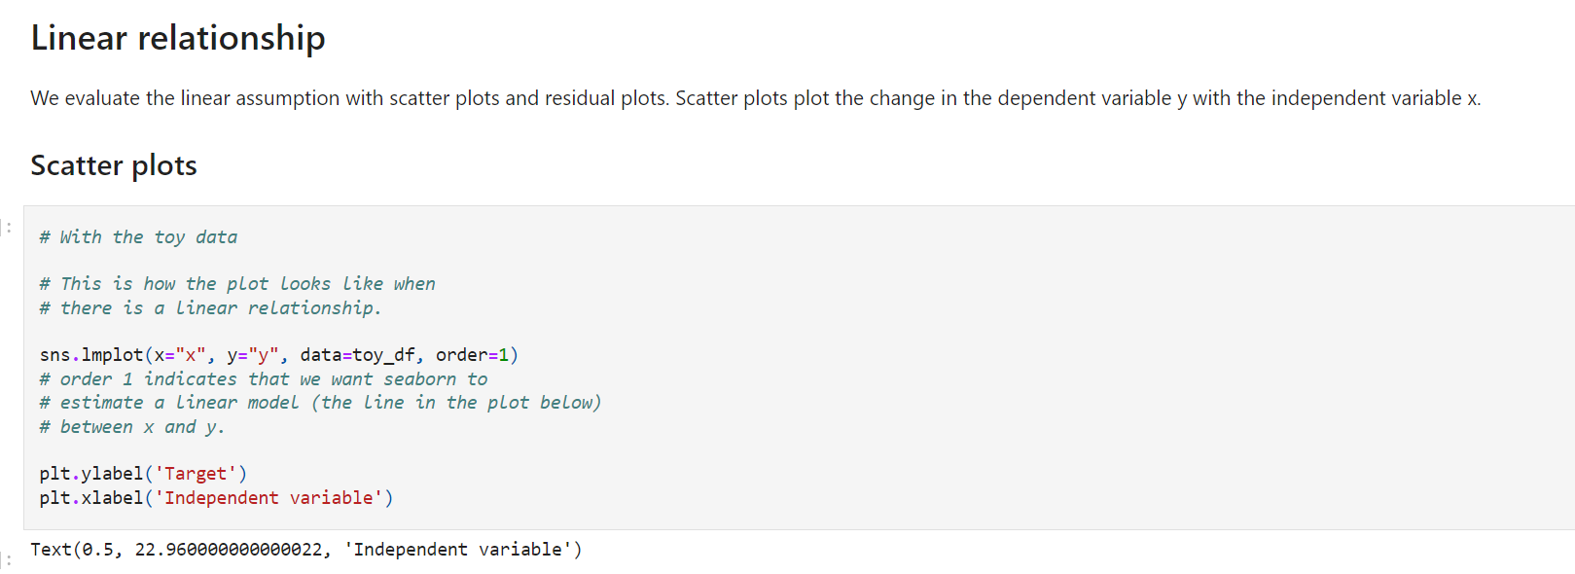

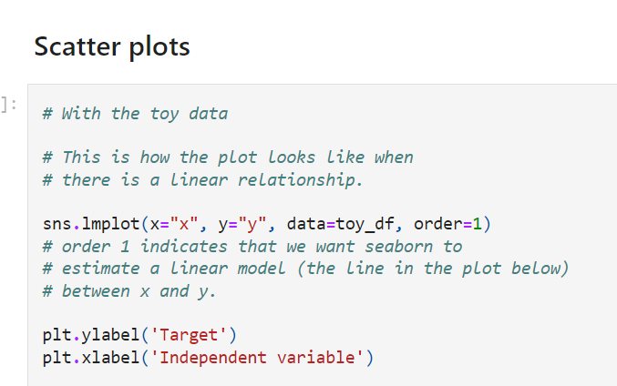

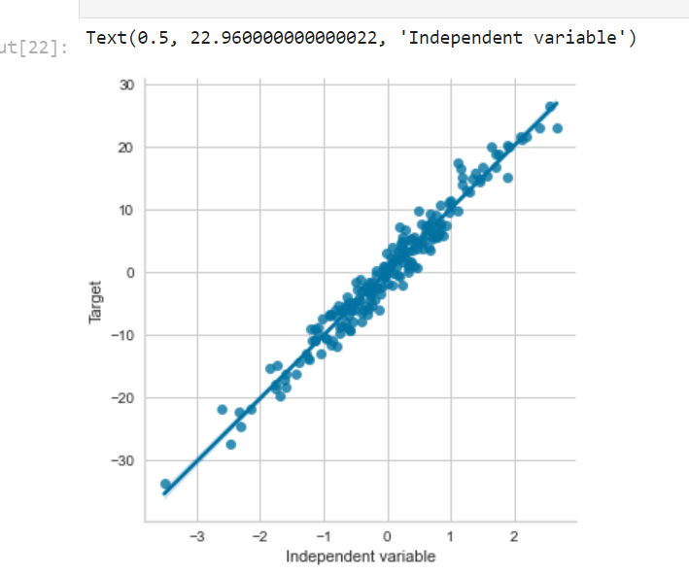

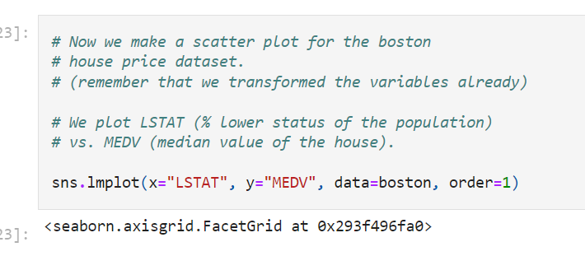

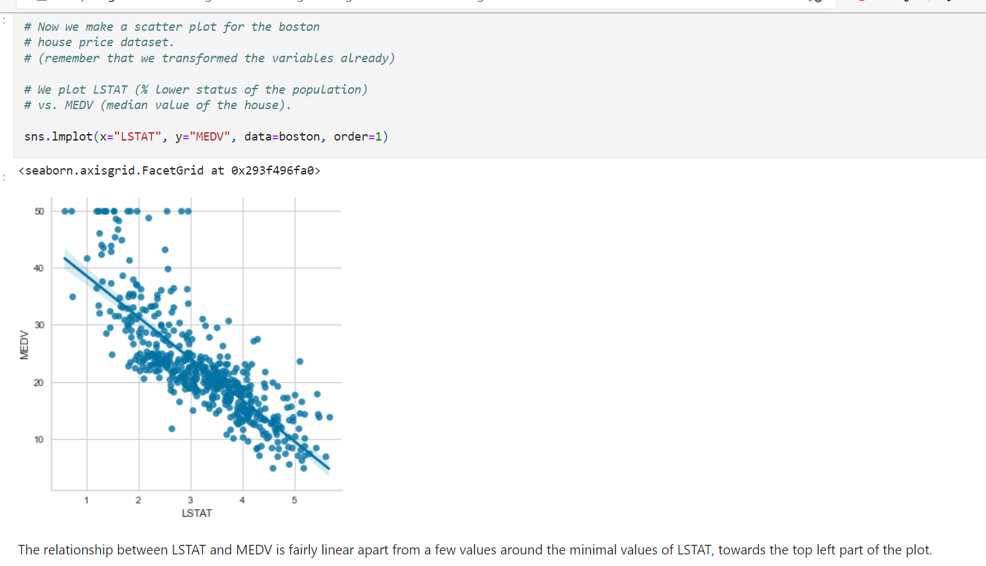

he relationship between LSTAT and MEDV is fairly linear apart from a few values around the minimal values of LSTAT, towards the top left part of the plot.

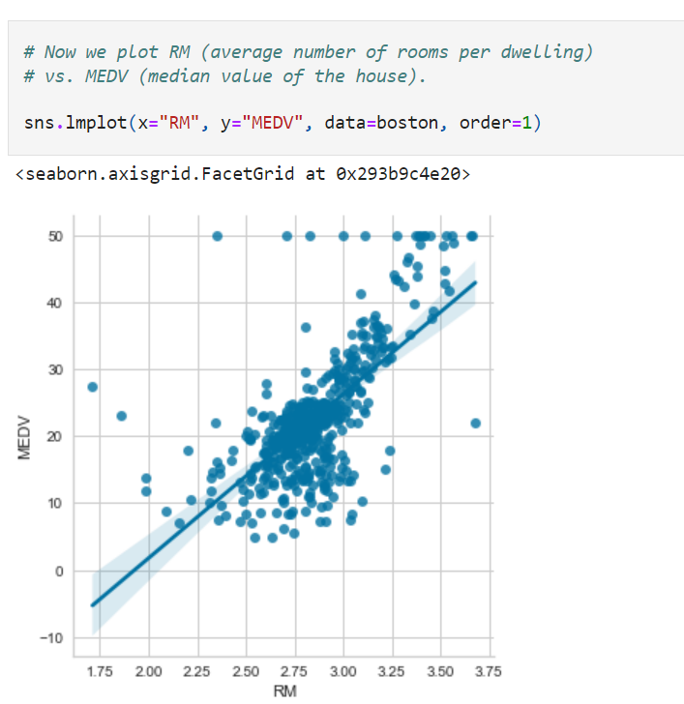

The relationship between the target and the **transformed RM is not linear.** We could consider, transforming this variable further, **removing the variable from the model,** or **using a non-linear model to predict MEDV from RM.**

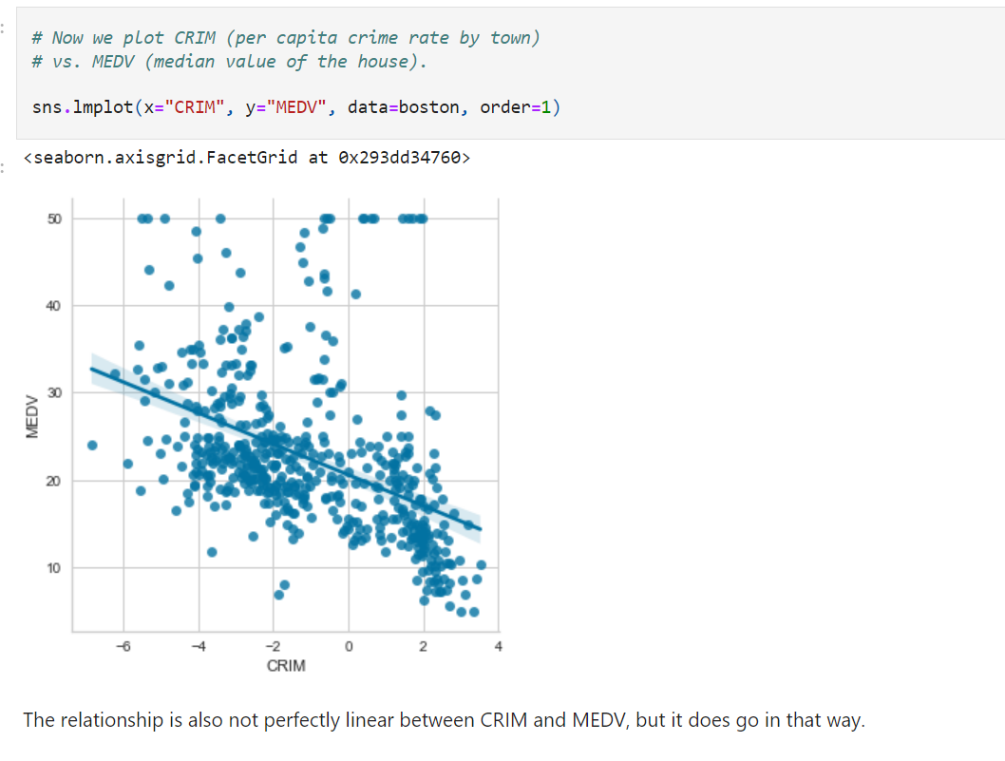

**Residual plots**

Another thing that we can do to determine whether there is a **linear relationship between the variable and the target** is to evaluate the **distribution of the errors,** o**r residuals**.

The **residuals refer** to the **difference between the predictions and the real value of the target**. It is performed as follows:

1) Train a linear regression model using the desired variables (X).

2) Obtain the predictions .

3) Calculate the error (the **difference between the true and predicted house prices**).

4) Examine the **error distribution.**

If the house price, in this case, MEDV, is linearly explained by the variables, then the **error should be random with a normal distribution centered at 0.**

We will first evaluate the toy dataset so that we become familiar with what the plots should look like. Then we will evaluate LSTAT and finally, we will transform LSTAT to see how the **transformation** affects the residuals and the linear fit.

**Note**

This is a bit of an over-kill if what we are trying to do is predict an outcome from predictor variables. However, you may want to do this to better understand the relationships between your variables and the target.

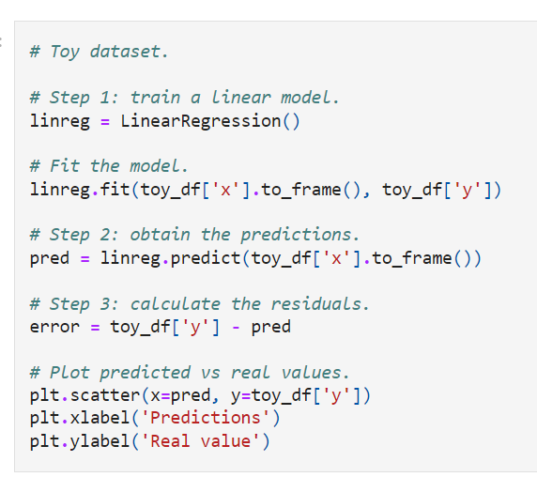

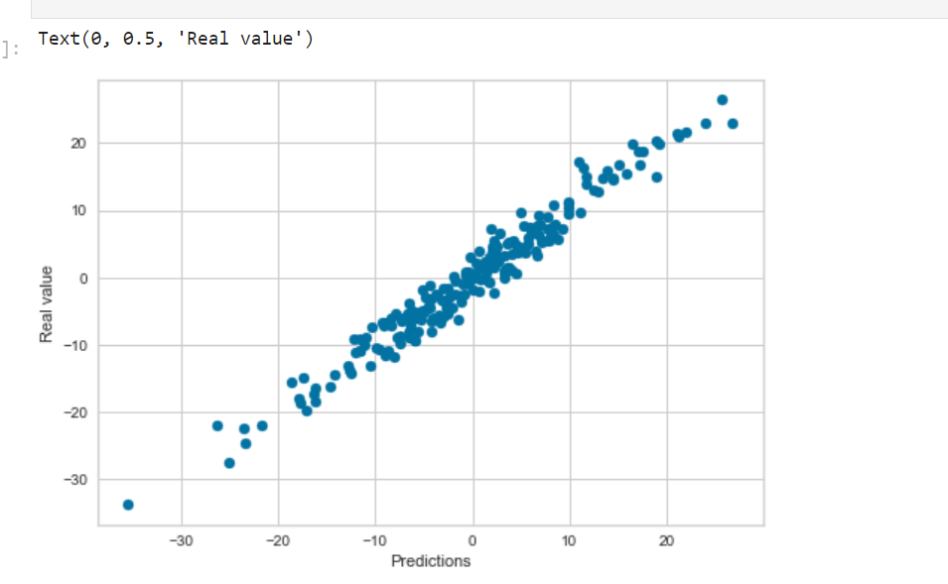

The model makes good predictions. The predictions are quite aligned with the real value of the target.

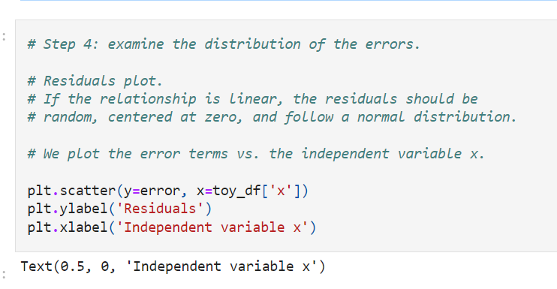

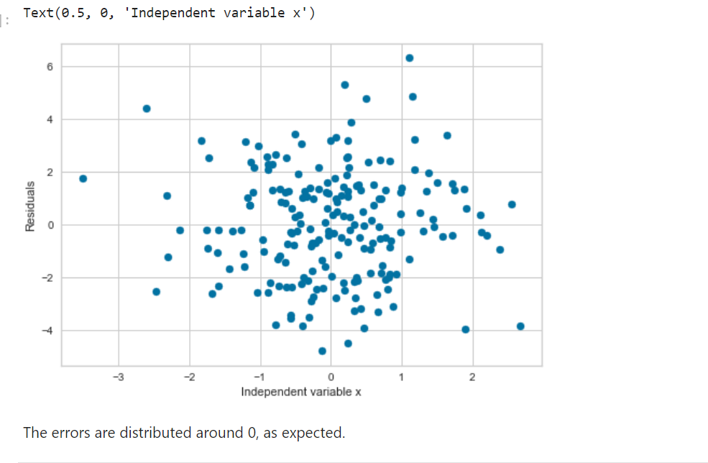

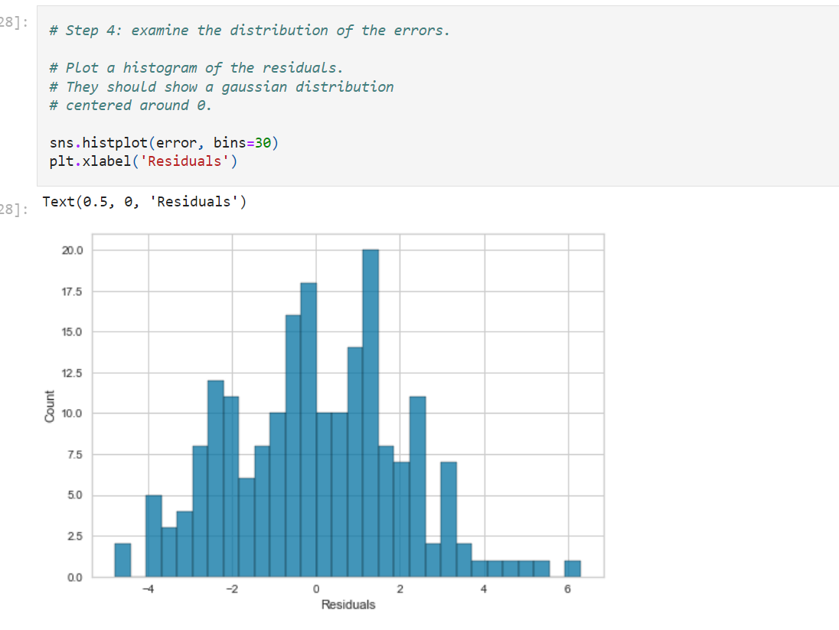

The errors show a **Gaussian distribution centered around 0.** So the variable meets the assumptions of the model.

Let's do the same for LSTAT (remember that we already transformed this variable).

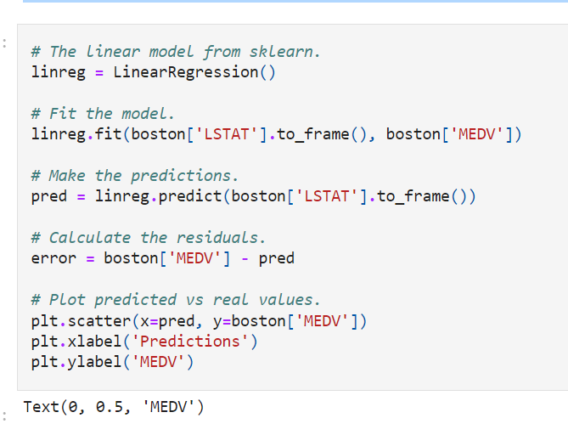

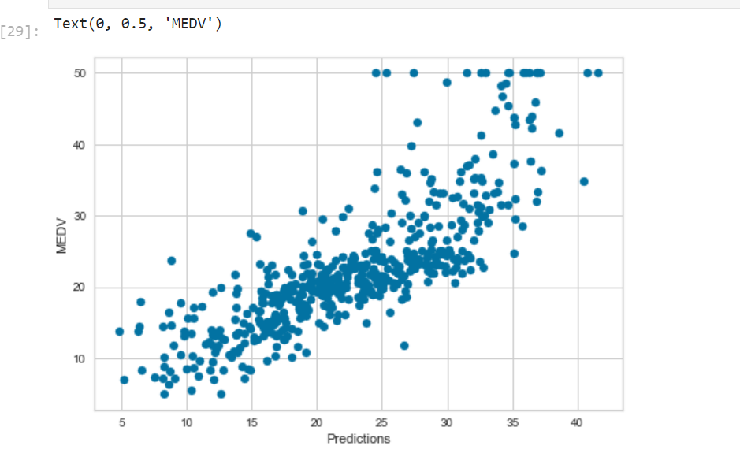

Most of the predictions are close to the real values. However, the model does not predict very well towards the highest house prices. For high house prices, the model under-estimates the price.

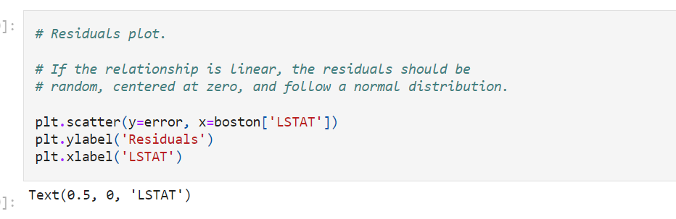

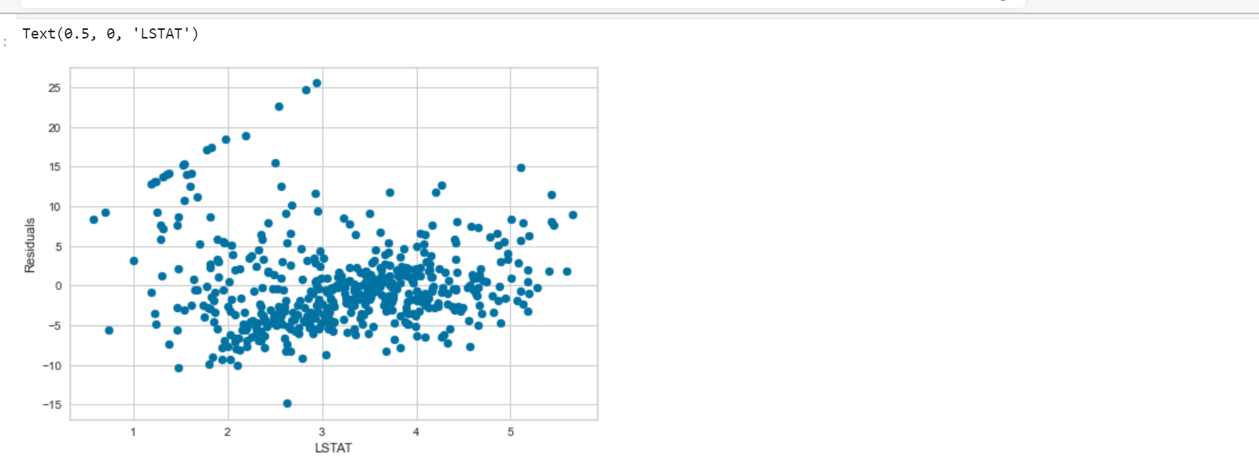

The residuals are not really centered at zero. The errors are not homogeneously distributed across the values of LSTAT. Low and high values of LSTAT show higher errors.

The relationship could be improved.

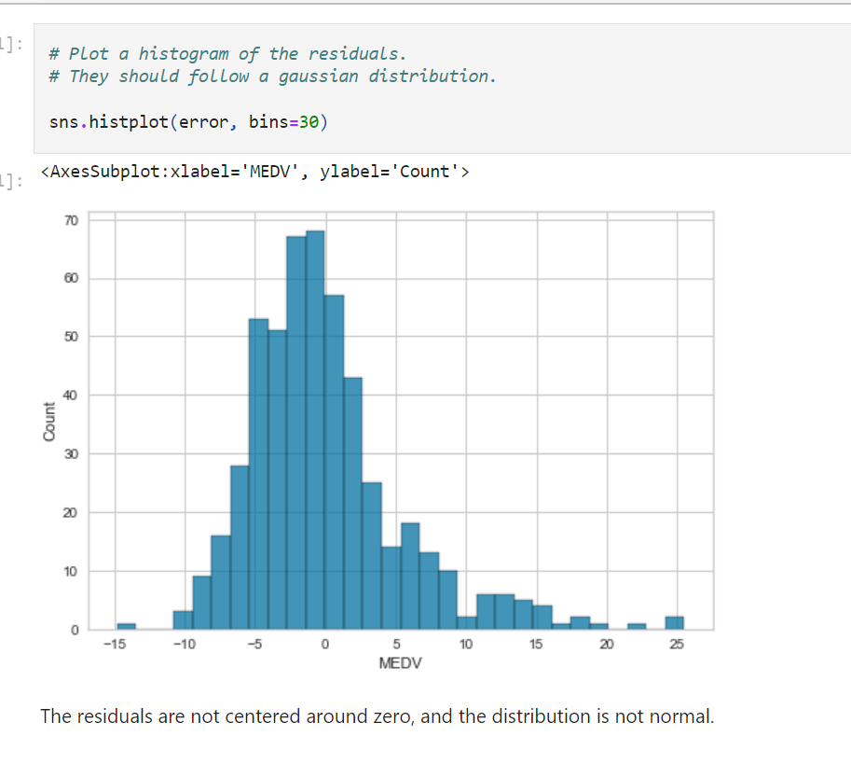

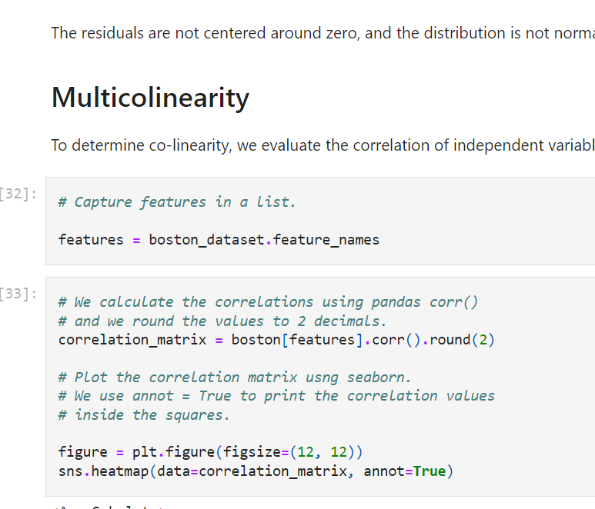

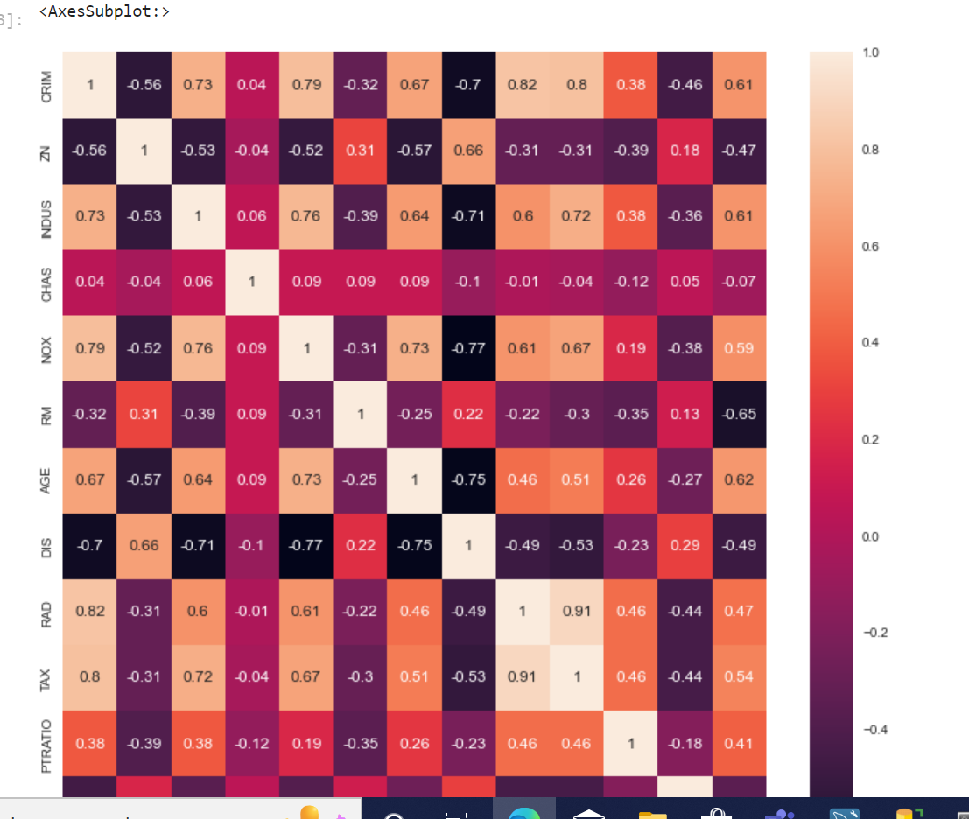

On the x and y axis of the heatmap, we see the variables of the Boston House dataframe. Within each square, the correlation value between those 2 variables is indicated. For example, for **LSTAT vs CRIM at the bottom left of the heatmap, we see a correlation of 0.46.** These two variables are not highly correlated.

Instead, for the **variables RAD and TAX** (try and find them in the plot), **the correlation is 0.91**. These variables are highly correlated. The same is true for the variables NOX and DIS, which show a correlation value of -0.71.

Let's see how they look in a scatter plot.

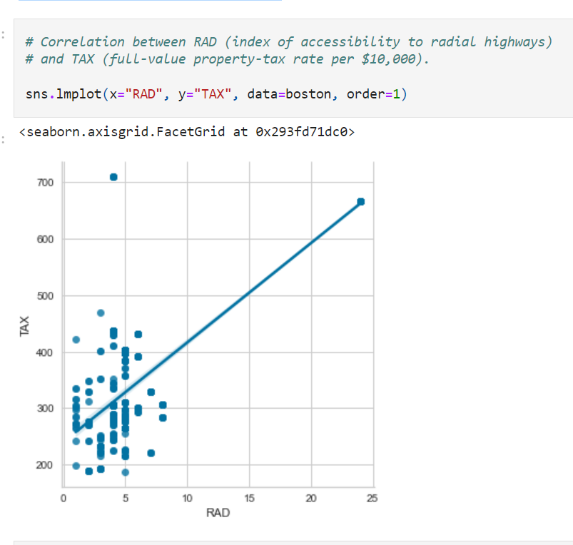

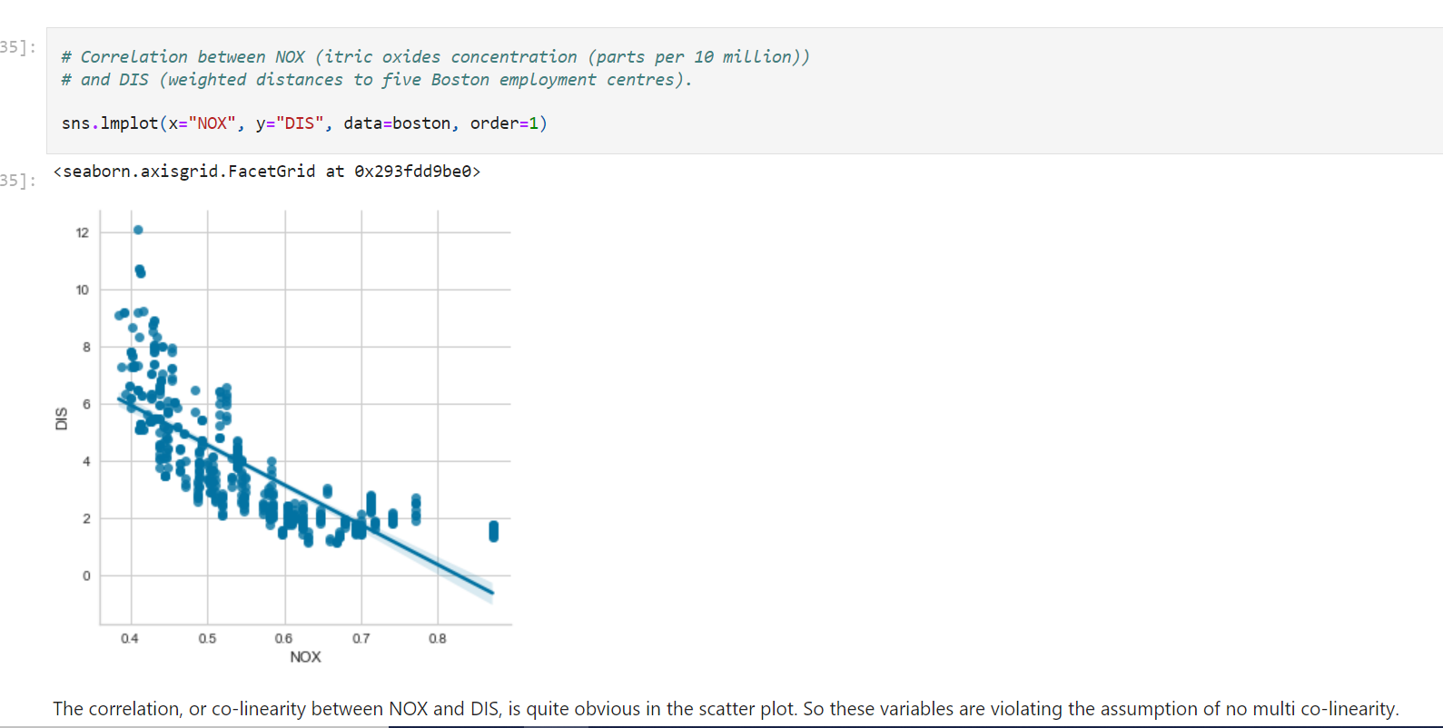

The correlation, or co-linearity between NOX and DIS, is quite obvious in the scatter plot. So these variables are violating the assumption of no multi co-linearity.

We could remove one of the variables before training the linear model.

**--**

**Variable distribution:**

**A prob of distribution is a function that describes the ikelihood of obtaining the possible values that a variable can take**

**For the variable height: prob distribution describes how often we can get a value of 161, 174,200**

**Values between 161-170**

**Prob distri: likelihood of an event occurrence**

**Sum of all prob=1**

**Particular value prob: must been 0 to 1**

**Disc: binomial, poison**

**Continued; guassian, skewd**

**--**

**Normal distribution :**

**Height, bp**

**Most of observations occur around the peak**

**Prob for values away from center decreases**

**Extream values: at tails , rare event**

**Skewed: one of tail longer than other**

**n.d= mean=mode=median**

**skewd: mean influenced by tail, positive skewed, mean at the right side**

**skewd: median**

**--**

**Residual normally distributed**

**How to make normal distribution:**

**Equal width bins (bins= max-min/num of bins)- doent improve spread**

**Equal freq bin= Bins determined by quantiles , equal number of observation for bin- improves spread**

**Outliers**

An outlier is a data point that is **significantly different from the remaining data.**

"An outlier is an observation that **deviates so much from the other observations** as to arouse suspicions that it was generated by a different mechanism." [D. Hawkins. Identification of Outliers, Chapman and Hall , 1980.]

**Should outliers be removed?**

**Depending on the context**, outliers either **deserve special attention or should be ignored**

**Attention**

**Unusual transactions in credit card**.

Take the example of **revenue forecasting**: if **unusual spikes of revenue are observed**, it's probably a good idea to pay extra attention to them and **figure out what caused the spike**. In the same way, an **unusual transaction on a credit card** might be a sign **of fraudulent activity,** which is what the **credit card issuer wants to prevent**. So, in instances like these, it is useful to look for and investigate further the outlier values.

If outliers are, **however, introduced by mechanical or measurement error**, it is a **good idea to remove these outliers** before training the model. Why? because some algorithms are sensitive to outliers.

**Machine learning models and outliers**

Some machine learning models are **sensitive to outliers**. For instance,

Adaboost:

**AdaBoost may treat outliers** as "hard" cases and **put tremendous weights on them**, thus producing a **model with poor generalisation.**

**Linear models,**

**i**n particular linear regression, can also be sensitive to outliers.

**Decision trees**-based models are **robust to outliers.** Decision trees make decisions by asking if variable x is >= than a certain value, and therefore the **outlier will fall on each side of the equation, but it will be treated similarly to non-outlier values.**

**Neural networks**

A research article suggests that **neural networks could also be sensitive to outliers**, provided the **number of outliers is high and the deviation is also high**. I would argue that if the number of outliers is high (> 15% as suggested in the article), then they are **no longer outliers, but rather a fair representation of that variable**. A link to this article can be found in the "Additional reading resources" lecture at the end of this section of the course.

**Identifying outliers**

**Outlier analysis and anomaly detection** is a huge field of research devoted to optimising methods and creating new algorithms to reliably identify outliers. There are plenty of ways to detect outliers in different situations. These are mostly targeted to identify outliers when those are the observations that we want to focus on, for example, fraudulent credit card activity.

In this course, however, we will focus on identifying outliers introduced by mechanical or measurement error. For this course, we won't be interested in the outliers per se, we just want to treat them before training our models.

Here, I will show you how to identify outliers. In later sections of the course we will learn how to preprocess them before training machine learning models.

**Extreme Value Analysis**

The most basic form of outlier detection is **Extreme Value Analysis** of 1-dimensional data.

The key to this method is to determine the statistical tails of the underlying distribution of the variable and then find the values that sit at the very end of the distribution.

If the variable is normally distributed (Gaussian), then the values that lie outside the mean, plus or minus 3 times the standard deviation of the variable, are considered outliers.

* **outliers = mean +/- 3* std.**

If the variable is skewed, a general approach is to calculate the quantiles, and then the inter-quartile range (IQR):

* **IQR = 75th quantile - 25th quantile**

An outlier will sit outside the following upper and lower boundaries:

* **Upper boundary = 75th quantile + (IQR * 1.5)**
* **Lower boundary = 25th quantile - (IQR * 1.5)**

or for extreme cases:

* **Upper boundary = 75th quantile + (IQR * 3)**
* **Lower boundary = 25th quantile - (IQR * 3)**

**Datasets for this demo:**

We will use the House Prices and Titanic datasets.

* To download the datasets please refer to the lecture **Datasets** in **Section 1** of the course.

We will also use the Boston house prices dataset from Scikit-learn:

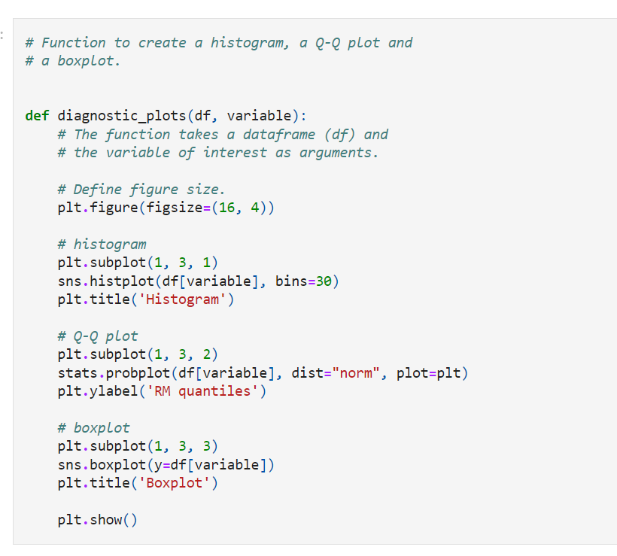

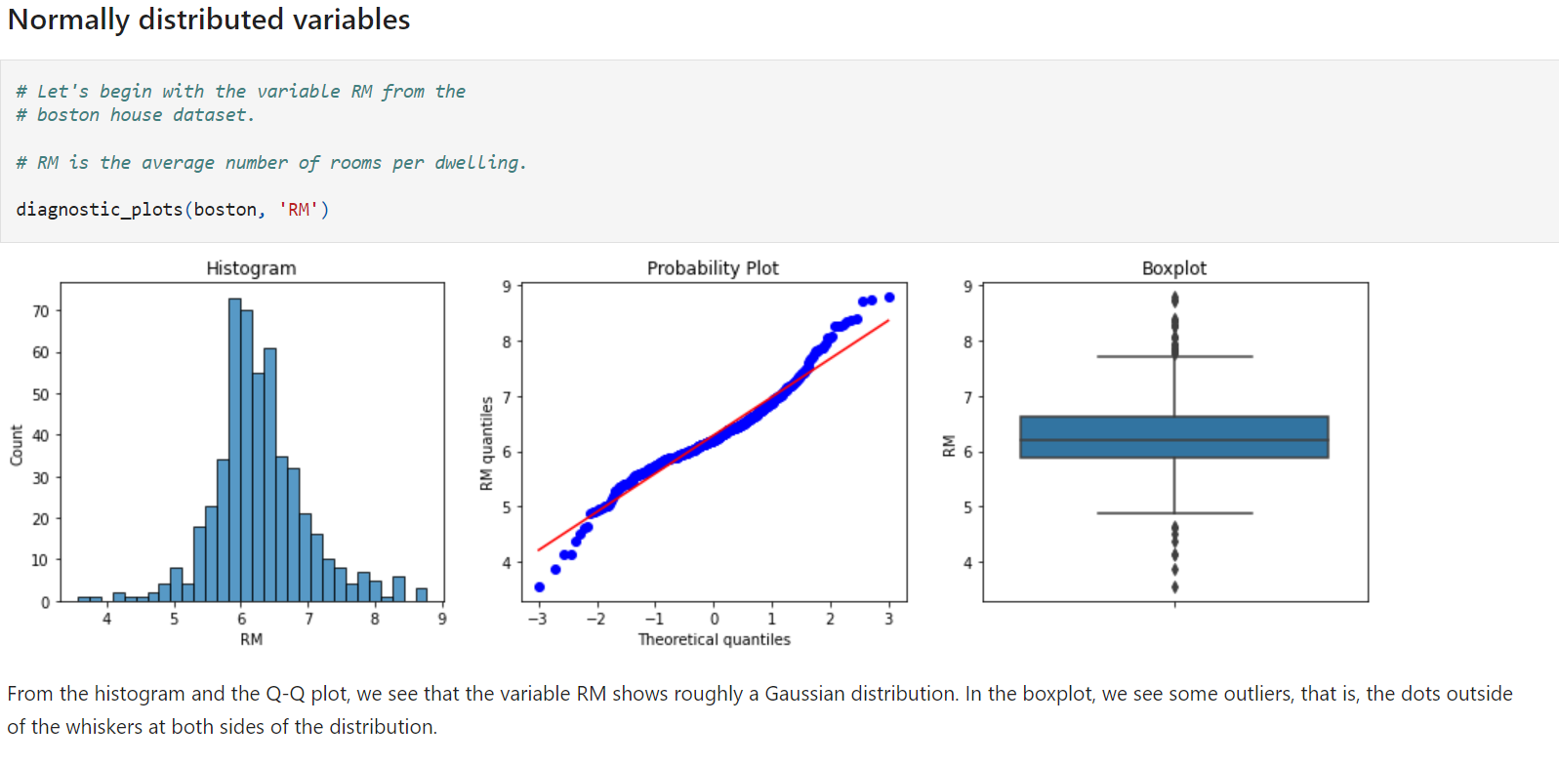

**Box plot**

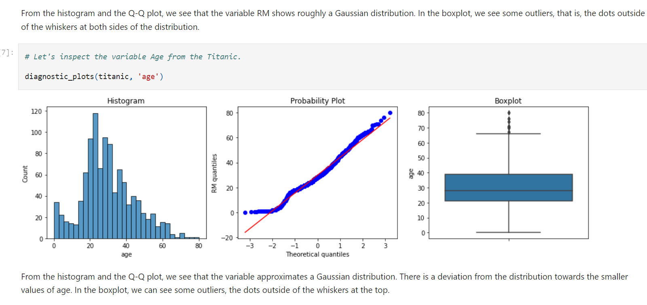

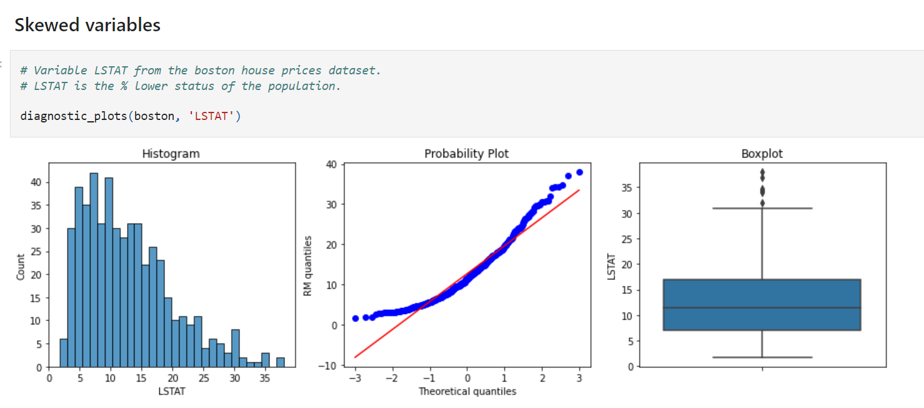

**Right skewed distribution – outliers will be on right side**

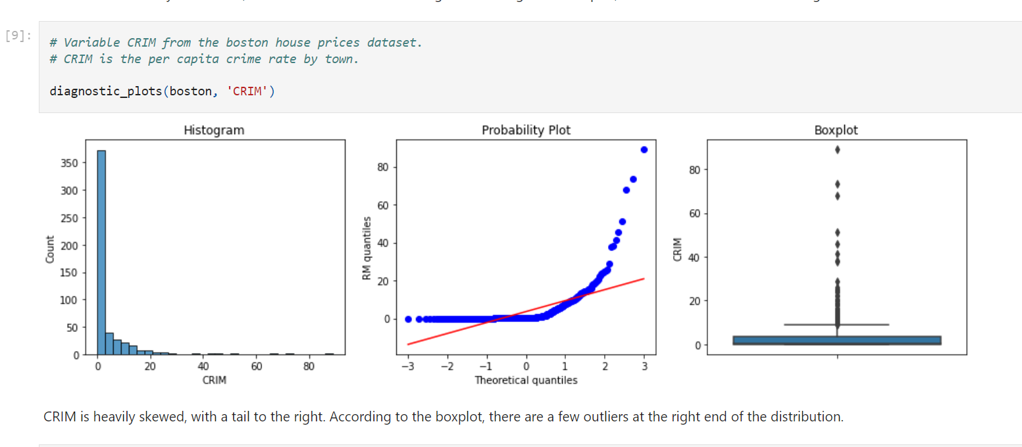

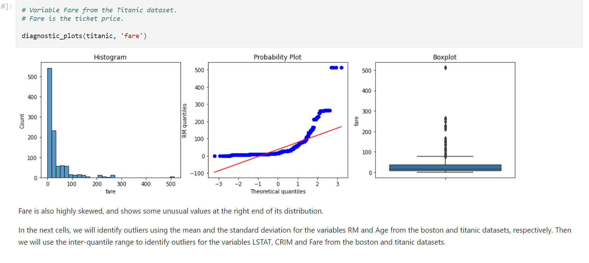

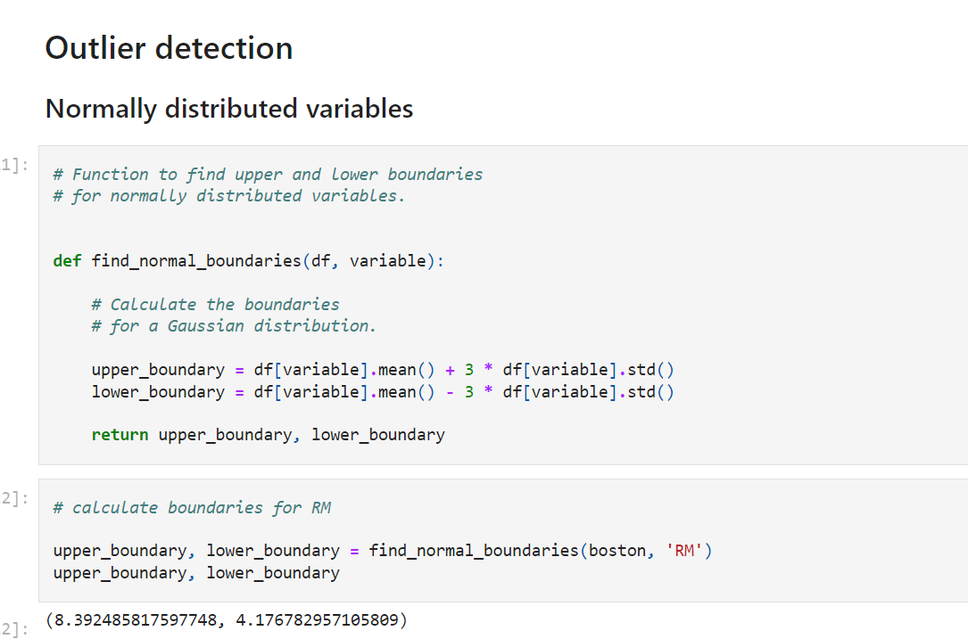

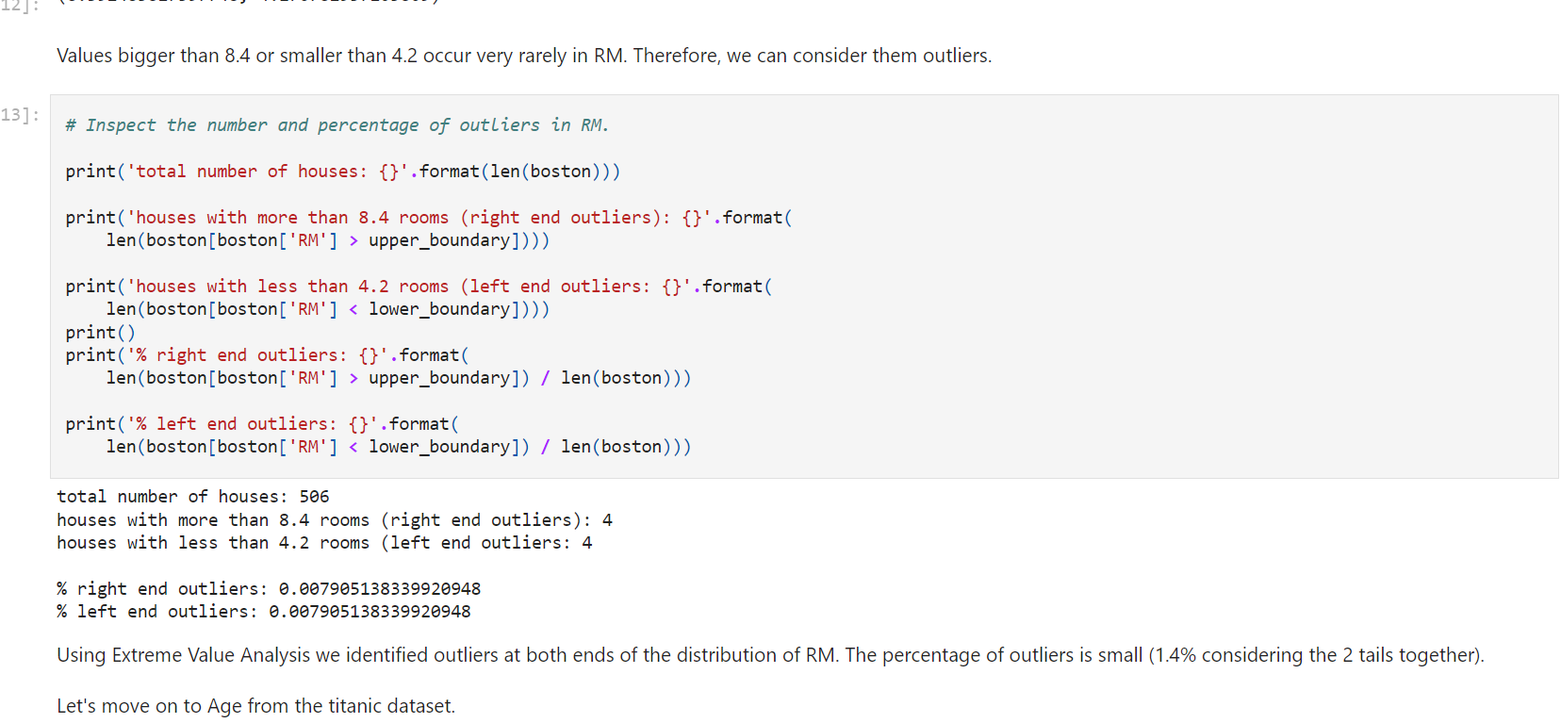

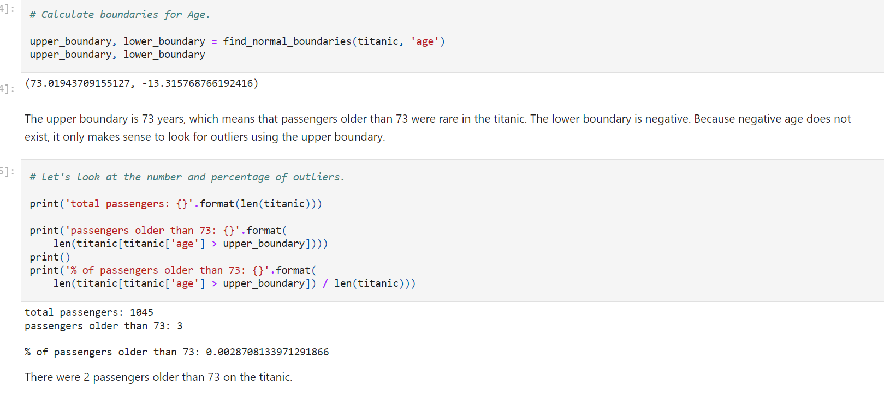

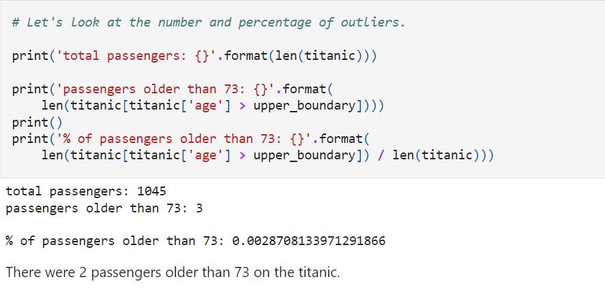

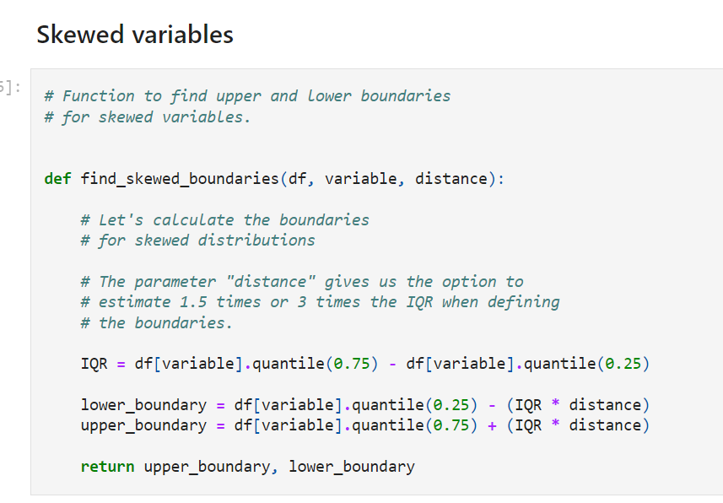

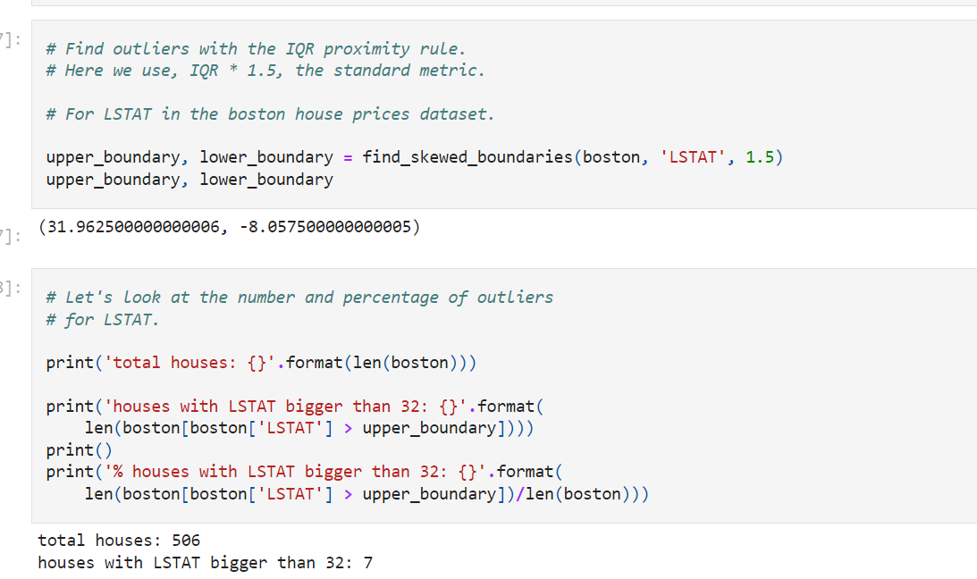



The upper boundary is ~32. The lower boundary is negative. However, the variable LSTAT does not take negative values. Thus, outliers in LSTAT will only be found beyond the upper boundary. This coincides with what we observed in the boxplot earlier in the notebook. Outliers were only found at the right tail of LSTAT's distribution.

We observe 7 houses, 1.3 % of the dataset, with extremely high values for LSTAT.

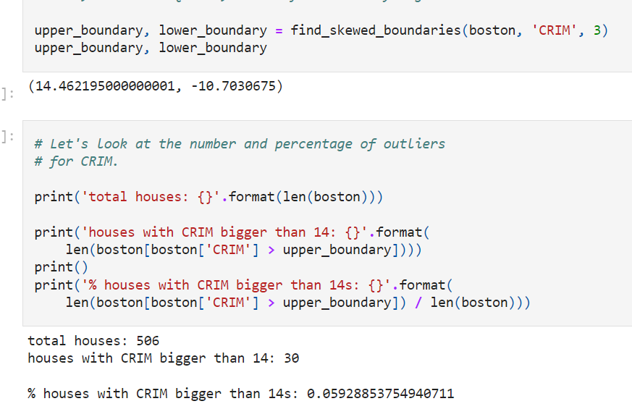

When using the 3 times the inter-quartile range to find outliers, we find that ~6% of the houses show unusually high crime rate areas. For CRIM as well, the lower boundary is negative, so it only makes sense to use the upper boundary to find outliers, as the variable takes only positive values. This coincides with what we observed in CRIM's boxplot earlier in this notebook.

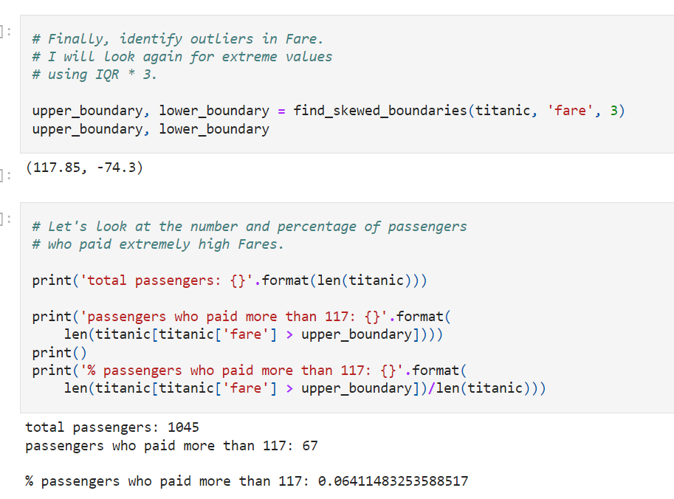

For Fare, as well as for all the other variables in this notebook which show a tail to the right, the lower boundary is negative. So we will use the upper boundary to find outliers. We observe that 6% of the values of the dataset fall above the boundary.

**That is all for this demonstration. I hope you enjoyed the notebook, and I'll see you in the next one.**

**Outliers:**

**Deviate from all other observation**

**Revenue for casting: pay extra attention**

**Credit card fraud transaction**

**--**

**Mechanical : can be ignored / removed**

**Box plot: viscous represents : lower and outer fench( less than or more than called outliers )**

**99 percent values should be within viscous**

**Skewed distribution: interquartile range conc where majority of values conc and median is opposite to extended tail**

**Variable magnitude**

**Does the magnitude matter?**

In linear regression models, the **scale of variables used to estimate the output matters**.

Linear models predict **y as follows: y = w x + b**,

where **the regression coefficient w represents the expected change in y** for a **unit change in** x (the predictor).

Thus**, the magnitude of w is partly determined by the magnitude of the units being used for x.**

If x is a distance variable, just changing the scale from kilometers to miles will cause a change in the magnitude of the coefficient.

In addition, when we estimate the outcome y using multiple predictors x1, x2,... , xn, variables with greater numeric ranges dominate those with smaller numeric ranges.

**Gradient descent converges faster** when all the **predictors (x1 to xn) are in a similar scale**. Thus, **having features in a similar scale is useful for neural networks.**

In support vector machines, **feature scaling can decrease the time it takes to find the support vectors.**

Finally, methods **using Euclidean distances or distances** in general are **also affected by the magnitude of the features,** as **Euclidean distance is sensitive to variations in the magnitude** or scale of the predictors. Therefore, feature scaling is required for methods that utilise distance calculations like **k-nearest neighbours (KNN) and k-means clustering.**

In summary:

**Magnitude matters because:**

* The **regression coefficient is** directly influenced by the **scale of the variable.**
* **Variables with a larger magnitude dominate** those with a **smaller magnitude.**
* **Gradient descent converges faster when features are on similar scales.**
* Feature scaling helps decrease the time it takes to find support vectors for SVMs.
* Euclidean distances are sensitive to feature magnitude.

**The machine learning models affected by the feature magnitude are:**

* Linear and Logistic Regression.
* Neural Networks.
* Support Vector Machines (SVMs).
* KNN.
* K-means clustering.
* Linear Discriminant Analysis (LDA).
* Principal Component Analysis (PCA).

**Machine learning models insensitive to feature magnitude are the ones based on trees:**

* Classification and Regression Trees.
* Random Forests (RF.
* Gradient Boosted Trees.

===================================================================================================

**In this Demo**

We will study the effect of feature magnitude on the performance of different machine learning models.

We will use the Titanic dataset.

* To download the dataset please refer to the **Datasets** lecture in **Section 1** of the course.

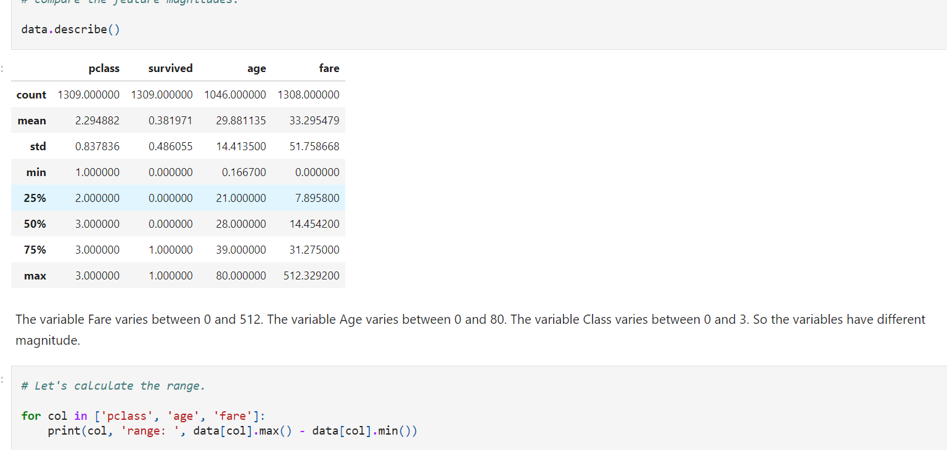

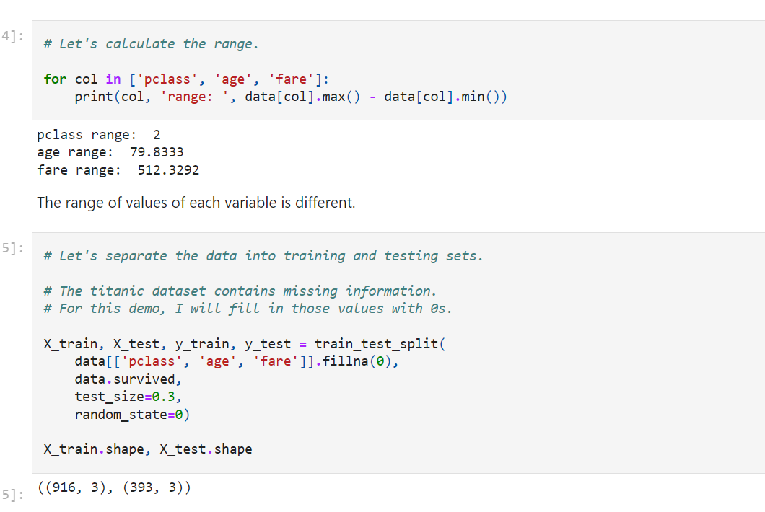

**Feature Scaling**

For this demonstration, I will scale the features between 0 and 1, using the [MinMaxScaler](http://scikit-learn.org/stable/modules/generated/sklearn.preprocessing.MinMaxScaler.html)from Scikit-learn.

The transformation is given by:

X_rescaled = X - X.min() / ( X.max() - X.min() )

And to transform the re-scaled features back to their original magnitude:

X = X_rescaled * (max - min) + min

**There is a section dedicated to feature scaling later in the course, where I will explain this and other scaling techniques in more detail**. For now, let's carry on with the demonstration.

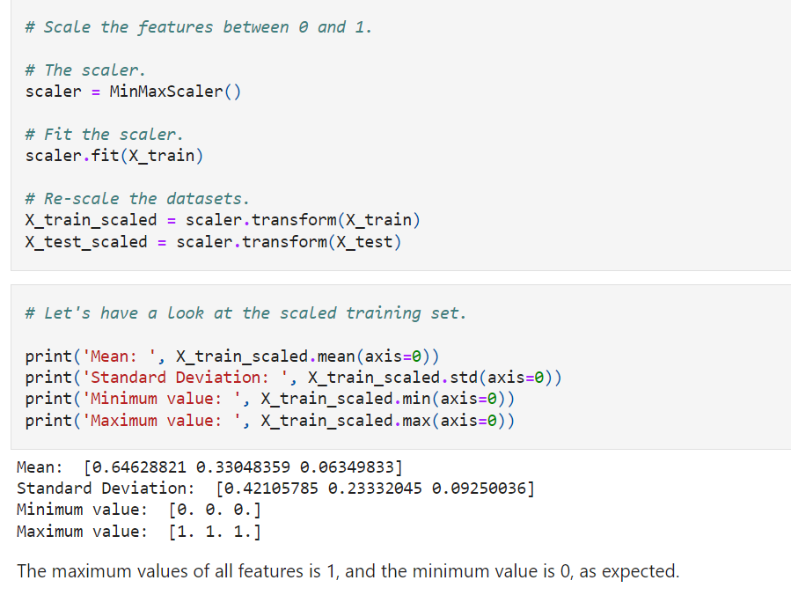

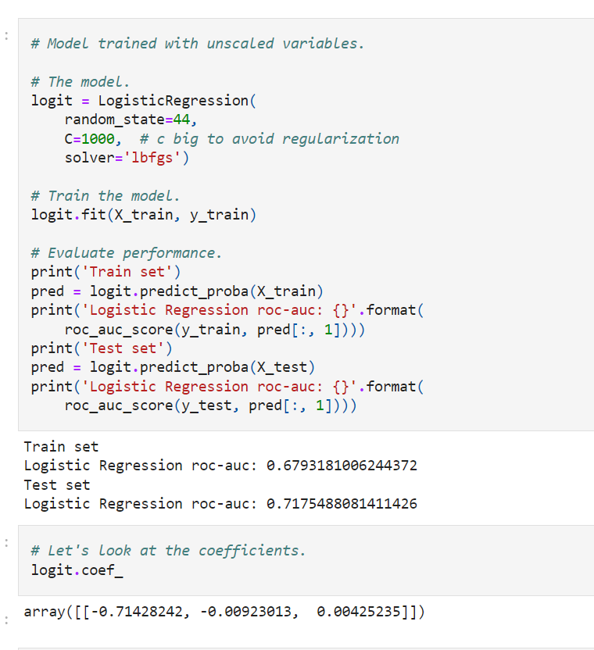

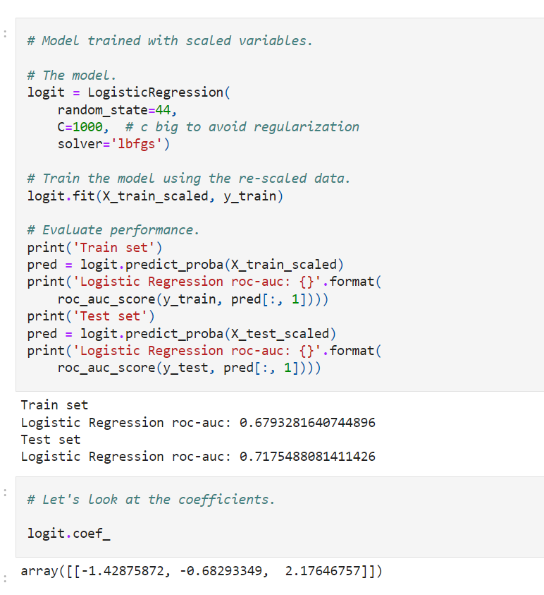

The performance of logistic regression did not change when using the datasets with the features scaled (compare ROC-AUC values for train and test set for models with and without feature scaling).

However, when looking at the coefficients, we do see a big difference in the values. This is because the magnitude of the variable affects the coefficients.

After scaling, all 3 variables have similar effect (coefficient) on survival, whereas before scaling, we would be inclined to think that Class was driving the survival outcome.

**Additional reading resources**

Overview of variable characteristics

* [Identifying common Data Mining Mistakes by SAS](https://www.mwsug.org/proceedings/2007/saspres/MWSUG-2007-SAS01.pdf)

Missing data

* [Missing data imputation, chapter 25](http://www.stat.columbia.edu/~gelman/arm/missing.pdf)

Linear and non-linear models

* [An introduction to Statistical Learning](http://www-bcf.usc.edu/~gareth/ISL/ISLR%20First%20Printing.pdf)
* [Elements of Statistical Learning](http://www-bcf.usc.edu/~gareth/ISL/ISLR%20First%20Printing.pdf)

Q-Q plots

* [Q-Q Plots in wiki](https://en.wikipedia.org/wiki/Q%E2%80%93Q_plot)
* [How to interpret a Q-Q plot](https://en.wikipedia.org/wiki/Q%E2%80%93Q_plot)
* [Q-Q Plot visualisation tool](https://xiongge.shinyapps.io/QQplots/)

Outliers

* [Why is AdaBoost algorithm sensitive to noisy data and outliers?](https://www.quora.com/Why-is-AdaBoost-algorithm-sensitive-to-noisy-data-and-outliers-And-how)
* [Why is Logistic Regression robust to outliers compared to least squares?](https://www.quora.com/Why-is-logistic-regression-considered-robust-to-outliers-compared-to-a-least-square-method)
* [Can Logistic Regression be considered robust to outliers?](https://www.quora.com/Can-Logistic-Regression-be-considered-robust-to-outliers)
* [The Effects of Outlier Data on Neural Networks Performance](https://www.researchgate.net/profile/Azme_Khamis/publication/26568300_The_Effects_of_Outliers_Data_on_Neural_Network_Performance/links/564802c908ae54697fbc10de/The-Effects-of-Outliers-Data-on-Neural-Network-Performance.pdf)
* [Outlier Analysis by C. Aggarwal](http://charuaggarwal.net/outlierbook.pdf)

Feature scaling

* [Should I normalize/standardize/rescale the data?](http://www.faqs.org/faqs/ai-faq/neural-nets/part2/section-16.html)
* [Efficient BackProp by Yann LeCun](http://yann.lecun.com/exdb/publis/pdf/lecun-98b.pdf)
* [Standardization and Its Effects on K -Means Clustering Algorithm](http://maxwellsci.com/print/rjaset/v6-3299-3303.pdf)
* [Feature scaling in support vector data description](http://rduin.nl/papers/asci_02_occ.pdf)

Overview of machine learning algorithms

* [Top 10 Machine Learning Algorithms](https://www.dezyre.com/article/top-10-machine-learning-algorithms/202)
* [Choosing the Right Algorithm for Machine Learning](http://www.dummies.com/programming/big-data/data-science/choosing-right-algorithm-machine-learning/)
* [Why does Gradient boosting work so well for so many Kaggle problems?](https://www.quora.com/Why-does-Gradient-boosting-work-so-well-for-so-many-Kaggle-problems)

**Kaggle kernels**

Titanic dataset

* [Exploring Survival on the Titanic](https://www.kaggle.com/mrisdal/exploring-survival-on-the-titanic)
* [Titanic Data Science Solutions](https://www.kaggle.com/startupsci/titanic-data-science-solutions/notebook)

House Sales Price dataset

* [Comprehensive Data Exploration](https://www.kaggle.com/pmarcelino/comprehensive-data-exploration-with-python)